How to Create a Welcome Banner
- Click the Create Guide button from the Guides Dashboard. Note: For steps to access the Guides Dashboard, refer to the Pendo for Beginners guide.
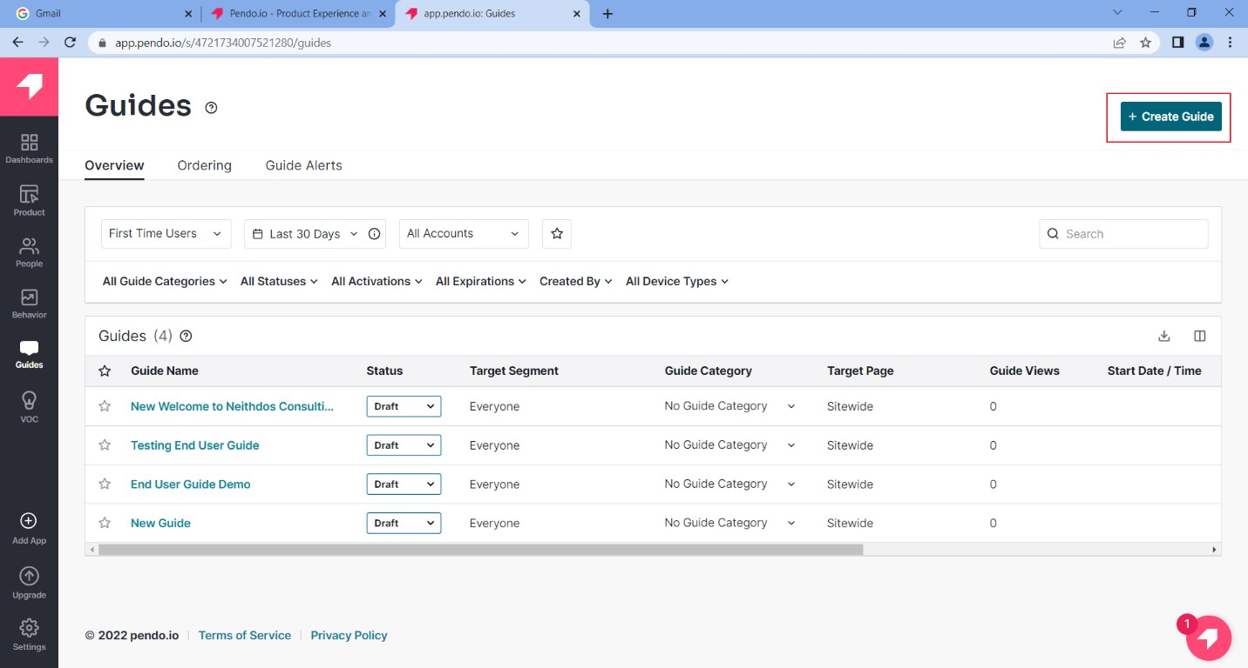
Figure 1: + Create Guide Button

- From the Default Layouts area of the Create Guide page, Click the “Select Layout” button on the New Feature Announcement Lightbox.
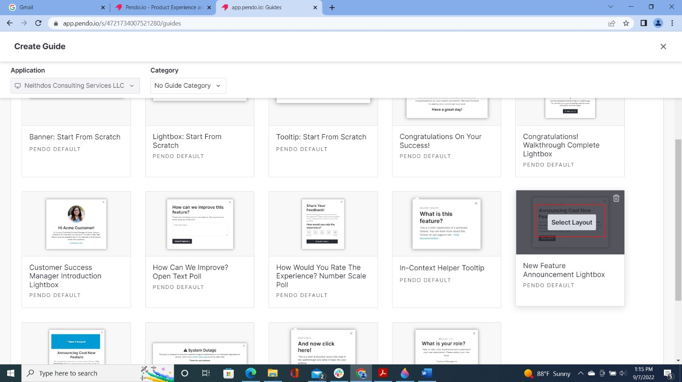
Figure 2: Lightbox - Select Layout

- On the upper left-hand corner of the Guide Settings page, insert a name for the Guide. This area is highlighted in blue.
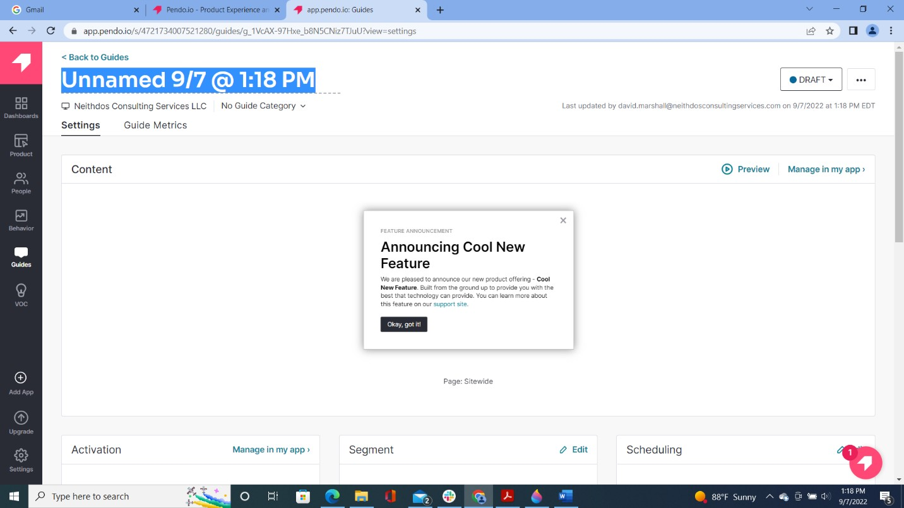
Figure 3: Add Name

- In the Content area, enter the website URL where the Welcome Banner will be displayed. For this guide, we will use https://www.neithdosconsultingservices.com.
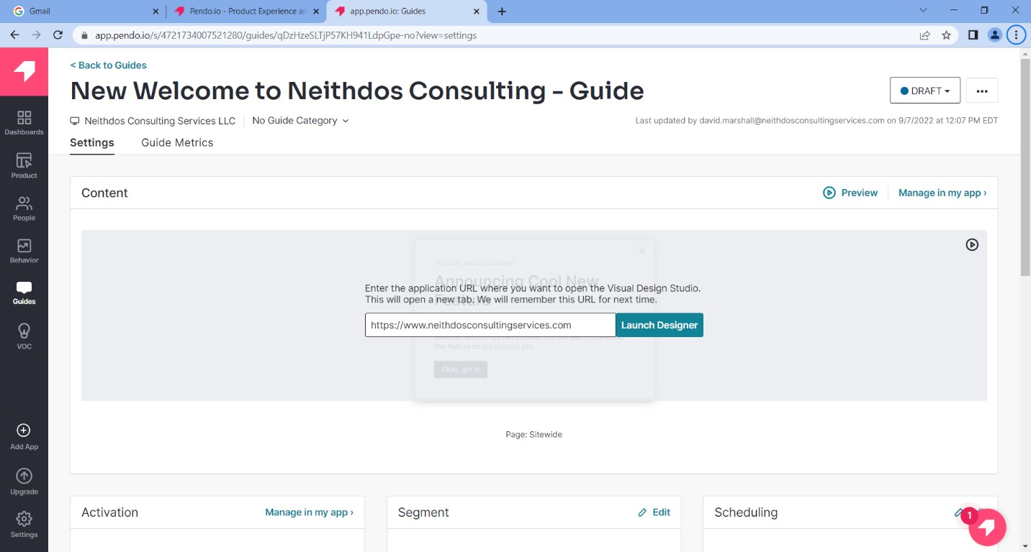

- Click Launch Designer
Figure 4: Content Area – URL

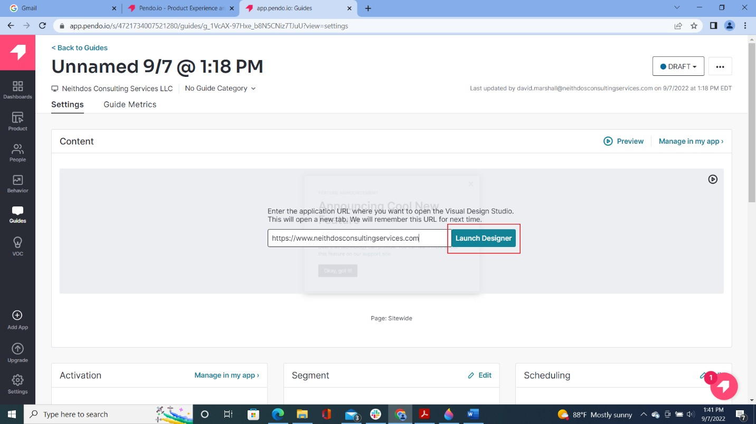
Figure 5: Content Area - Launch Designer button

- On Feature Announcement, click on the Title. The Edit Text menu will appear on the left-hand side.
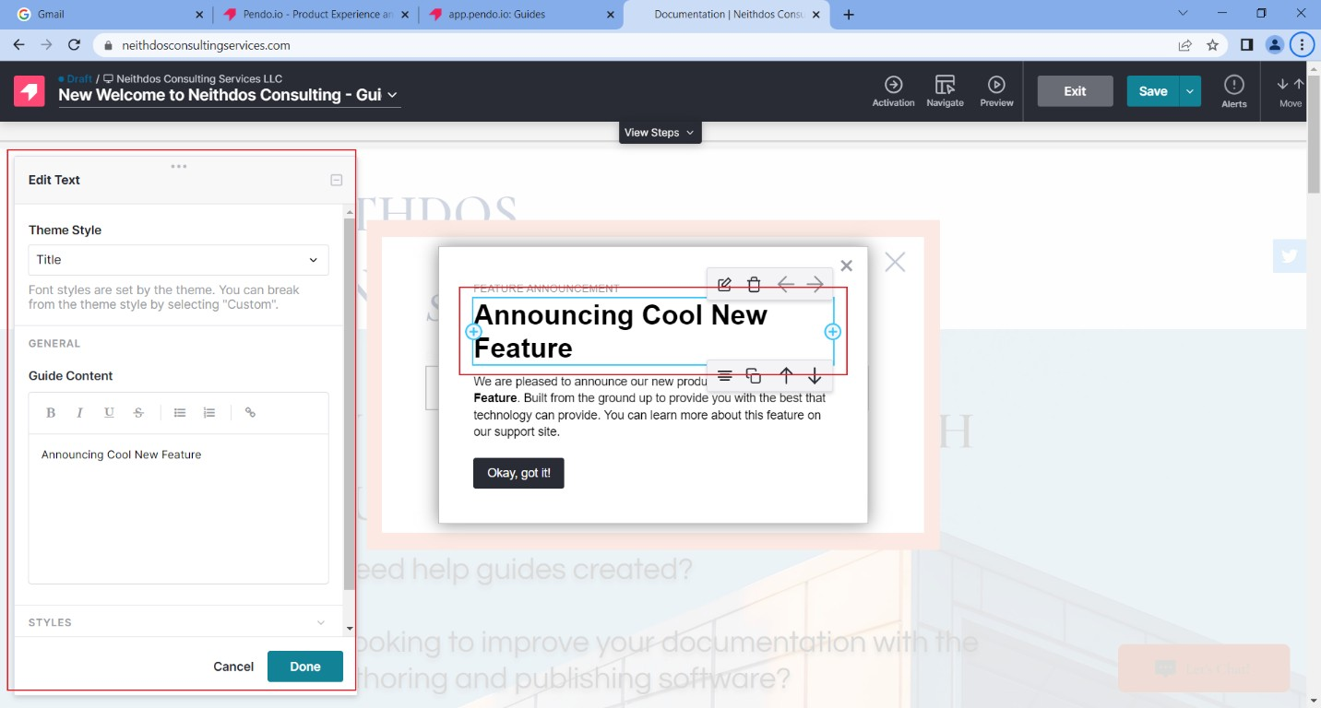
Figure 6: Features Announcement Box - Edit Text

- In the Guide Content Section of the Edit Text menu, change the title to “Welcome to Neithdos Consulting.”
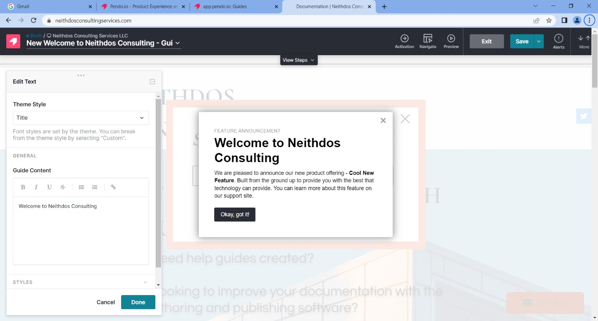
Figure 7: Title - Welcome to Neithdos Consulting

- Click the Done button.
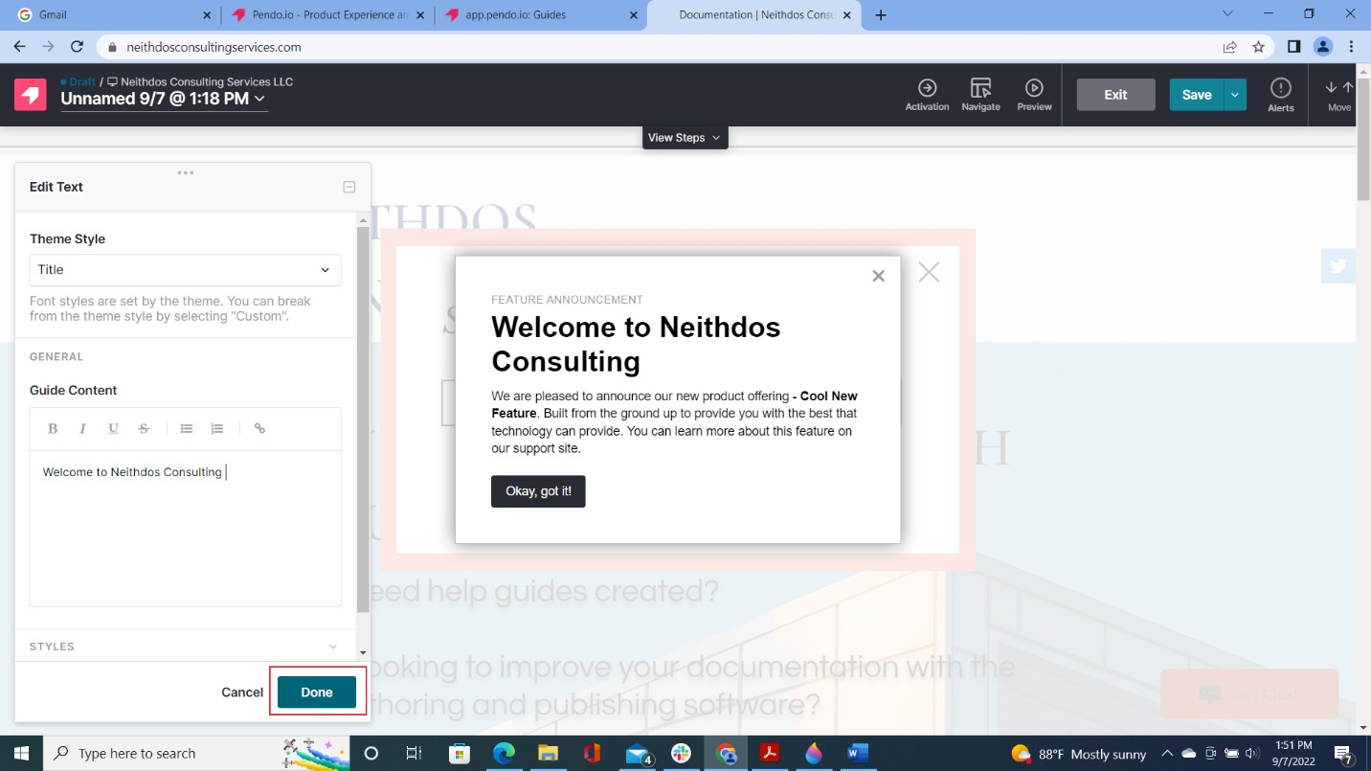
Figure 8: Title - Done button

- In the Feature Announcement section, click on the paragraph below the title.
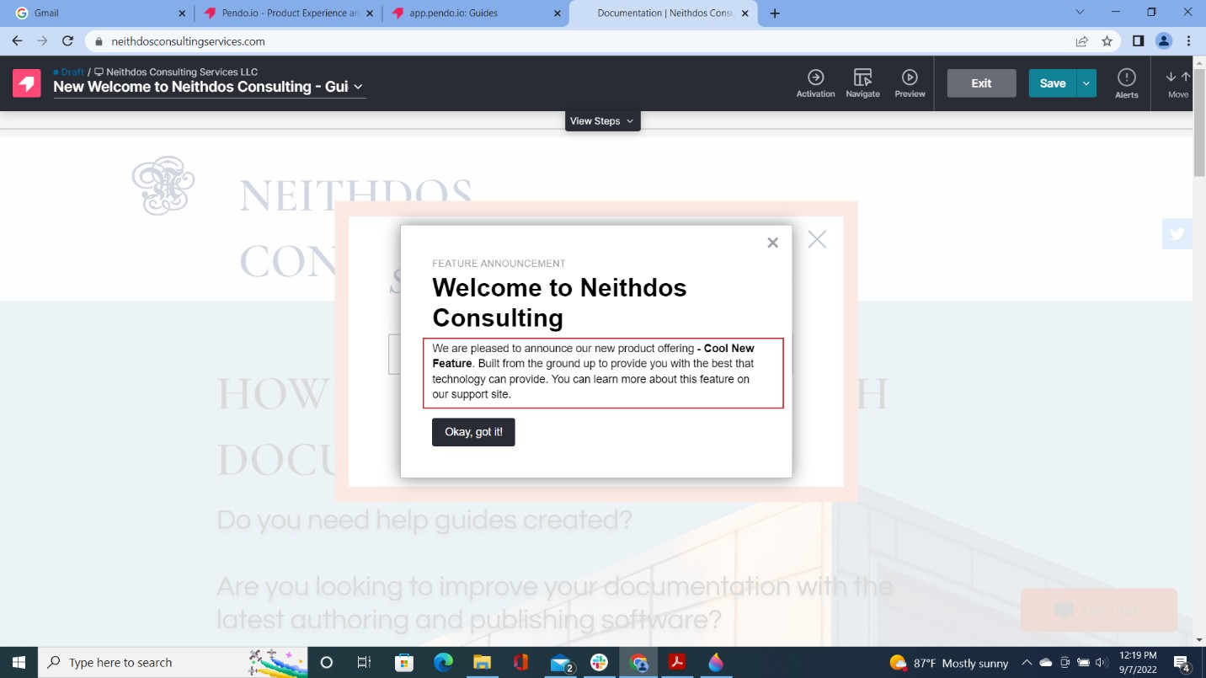
Figure 9: Paragraph area

- In the Guide Content section of the Edit Text menu, modify the paragraph at your discretion.
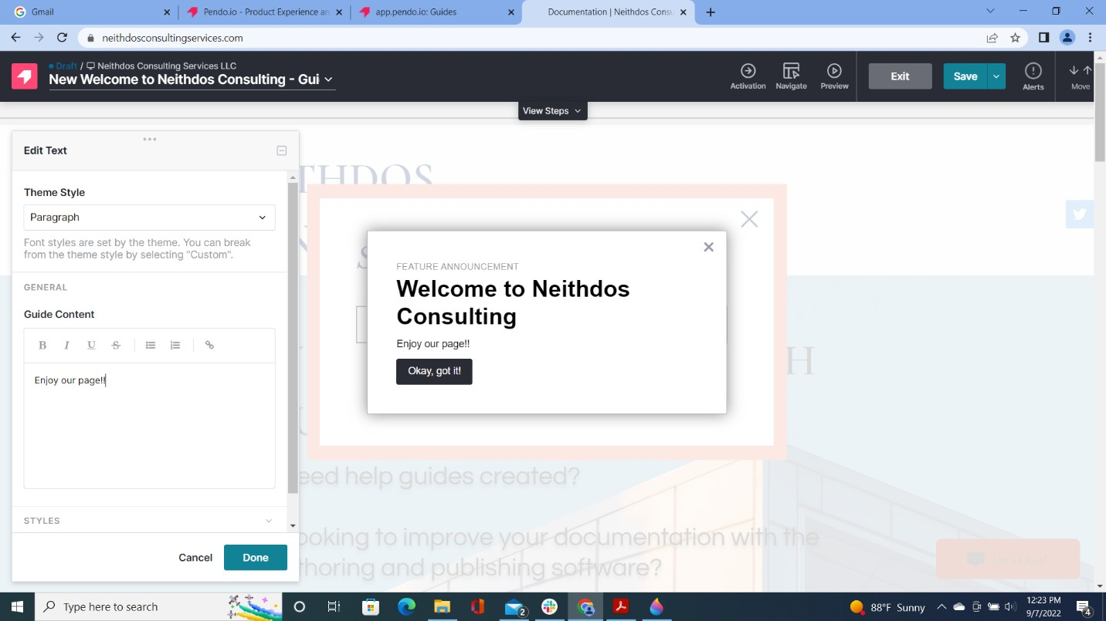

- Click Done
Figure 10: Modify Paragraph

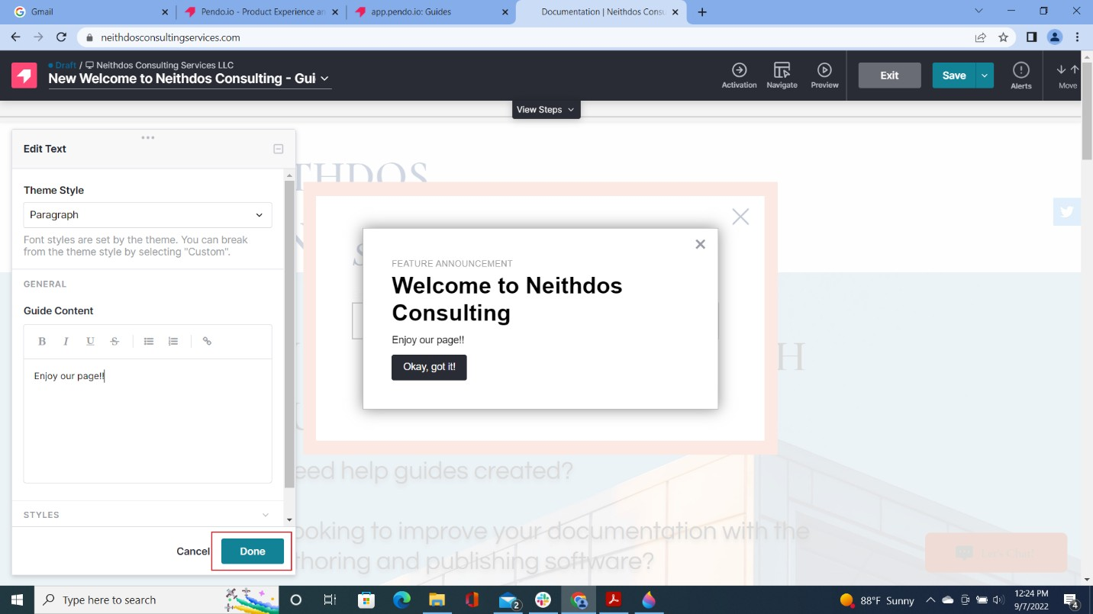
Figure 11: Paragraph - Done button

- Click Save
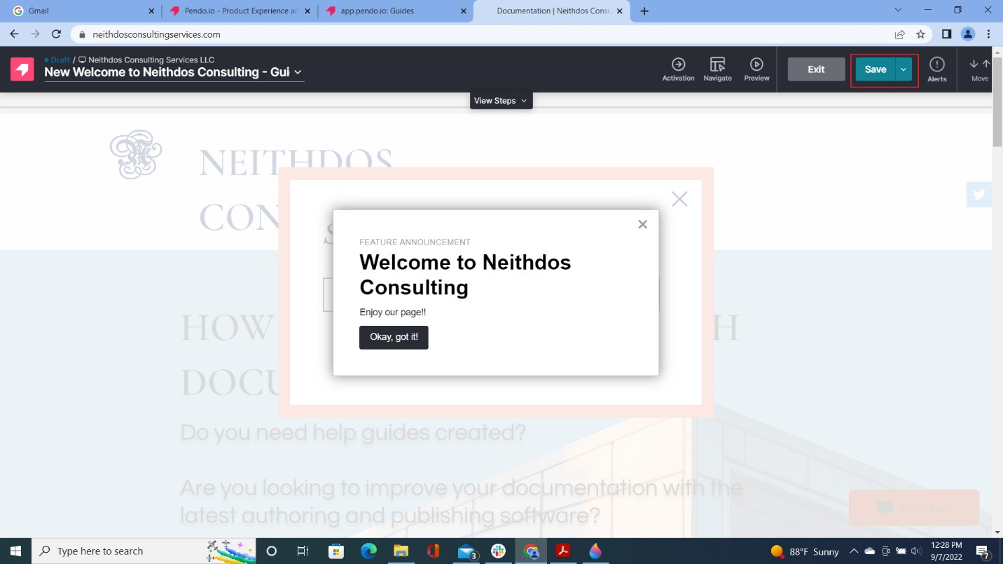

- Click Exit
Figure 12: Save button

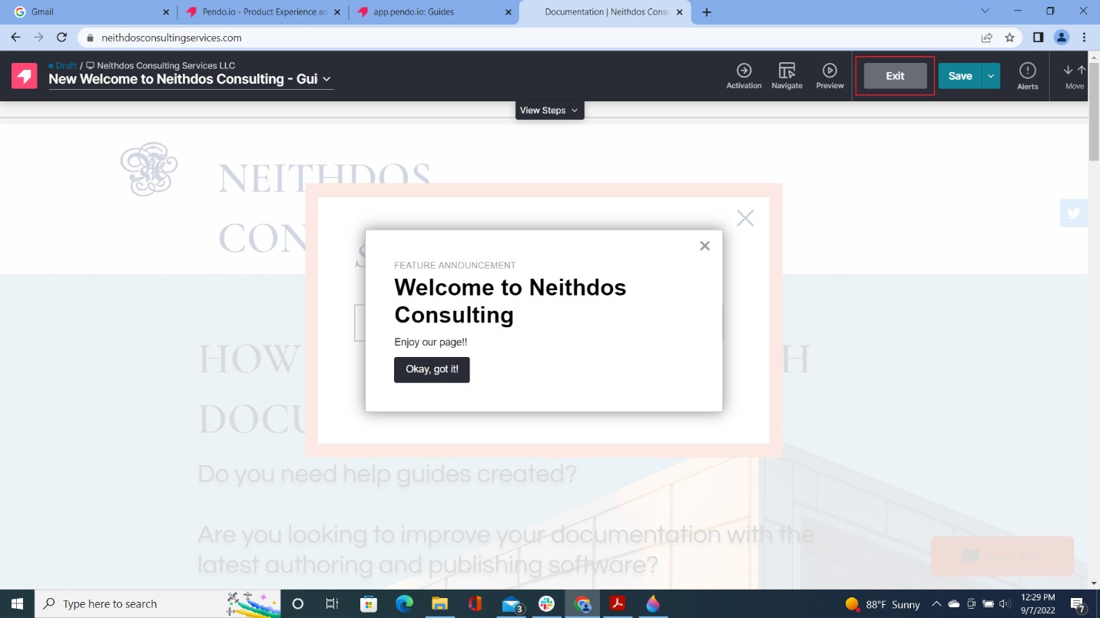

- Click Preview
Figure 13: Exit button

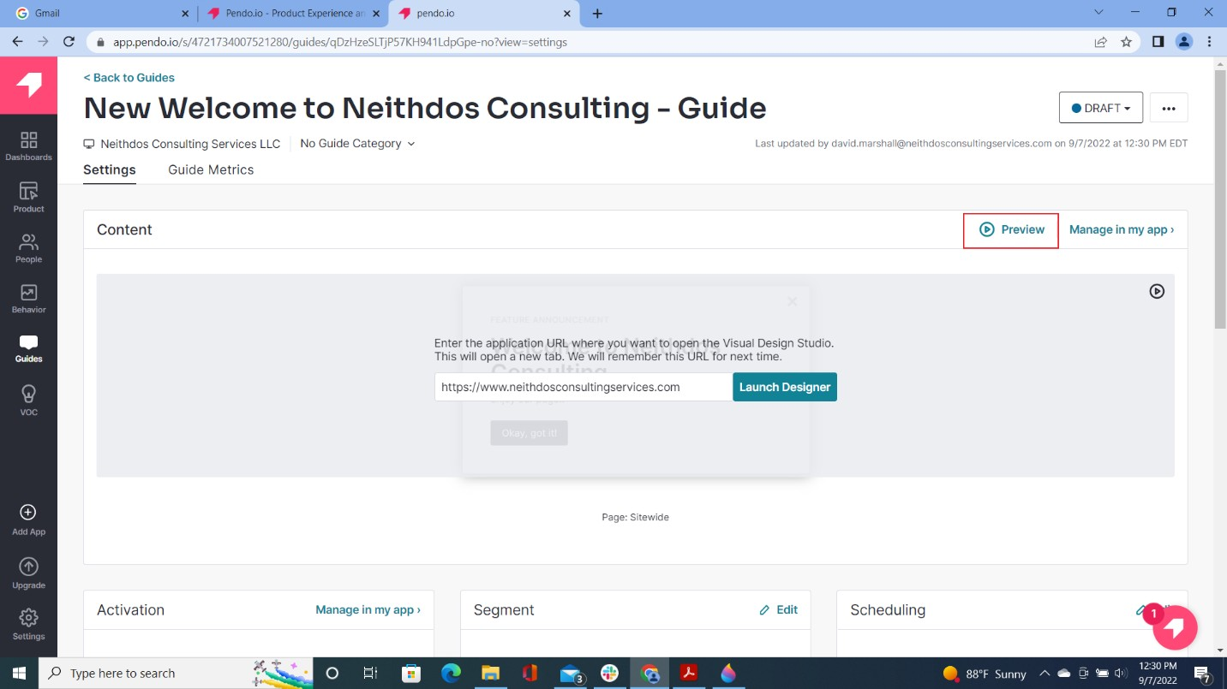
Figure 14: Preview

- Confirm that the banner is displayed on the website. Click Exit Preview.
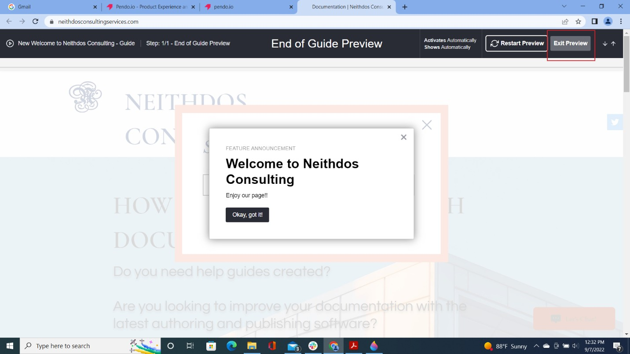
Figure 15: Confirming Banner Exit Review

