Pendo User Guide

FOR

Beginners



Version 1.0

2024 August 22

Revision History
The table below identifies all changes that have been incorporated into this document.
Version | Draft Date | Summary of Change | Point of Contact
1.0 | 8/22/2024 | Initial | Neithdos

Table of Contents

Introduction 1
Steps 1

List of Figures

Figure 1: Pendo Welcome Page 1
Figure 2: Pendo Log In button 1
Figure 3: Enter email address 2
Figure 4: Sign In button 2
Figure 5: Password page 3
Figure 6: Sign In button 3
Figure 7: Pendo dashboard 4
Figure 8: Pendo Resource Center 4
Figure 9: Guides option 5
Figure 10: Guides option from the Guide menu 6
Figure 11: Guides dashboard 6
Figure 12: +Create Guide button 7
Figure 13: Theme pull-down menu 7
Figure 14: Selecting Theme 8
Figure 15: Create a name for Guide 8
Figure 16: Enter URL 9
Figure 17: Launch Designer 9
Figure 18: +Click to Add Content 10
Figure 19: Text option 11
Figure 20: Custom option 11
Figure 21: Customer message 12
Figure 22: Save button 13
Figure 23: Exit button 14
Figure 24: Preview option 14
Figure 25: Website message 15
Figure 26: Exit Preview 15
Figure 27: Back to Guides 16
Figure 28: The newly created guide is listed 16

Introduction

This user guide is for beginners using the Pendo product for the first time. In this guide, we will create a welcome message.

Steps

- Type https://www.pendo.io in the web address bar.
  - Note: For the best results, you should use Google Chrome.

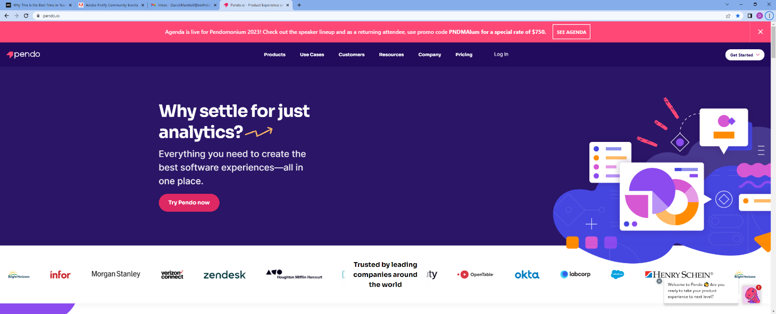
Figure 1: Pendo Welcome Page
- Click Log in on the toolbar.

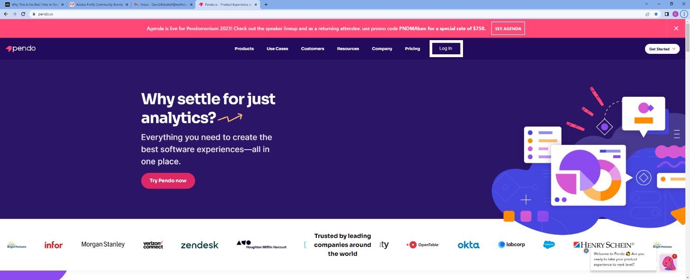
Figure 2: Pendo Log In button

- Enter the email address associated with the account.

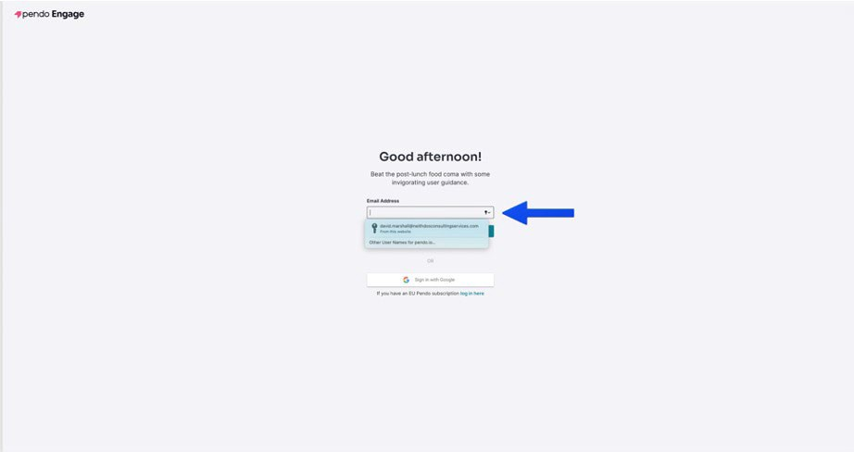
Figure 3: Enter email address
- Click Sign In.

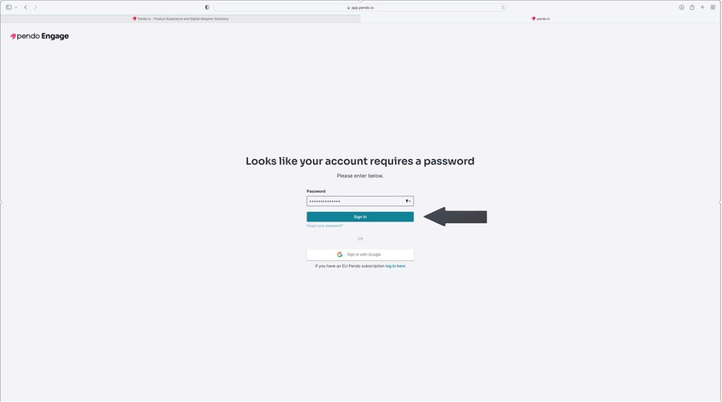
Figure 4: Sign In button

- Enter the account password.

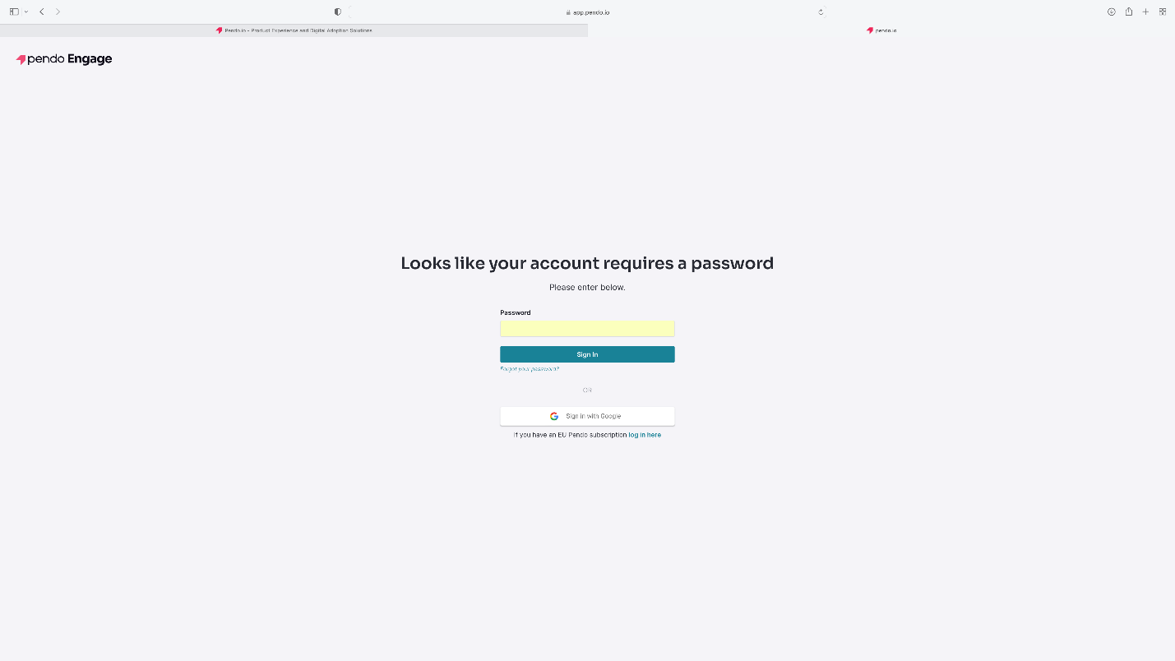
Figure 5: Password page
- Click Sign In.

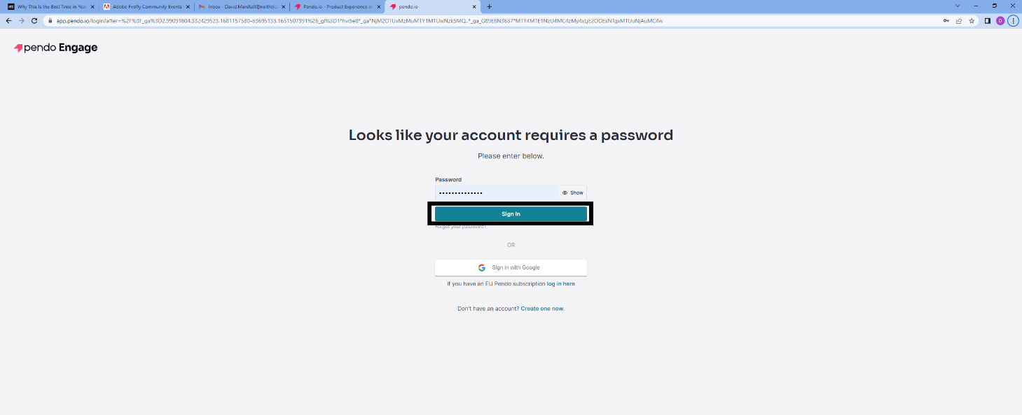
Figure 6: Sign In button

- The Pendo Dashboard displays

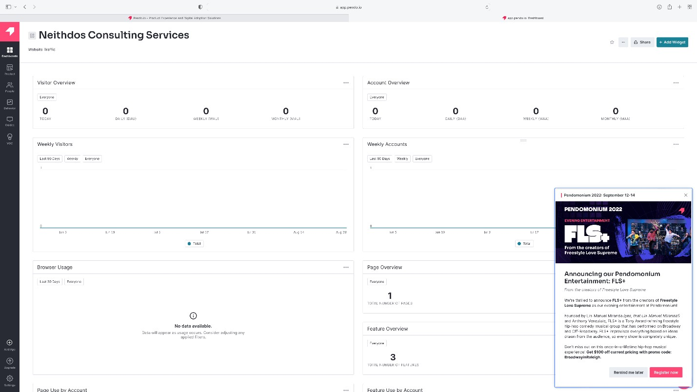
Figure 7: Pendo dashboard
- To view the announcements, click on the Pendo logo on the lower right-hand corner of the dashboard. The Resource Center opens, displaying the notifications. To exit the Resource Center, click “X” in the upper right corner.

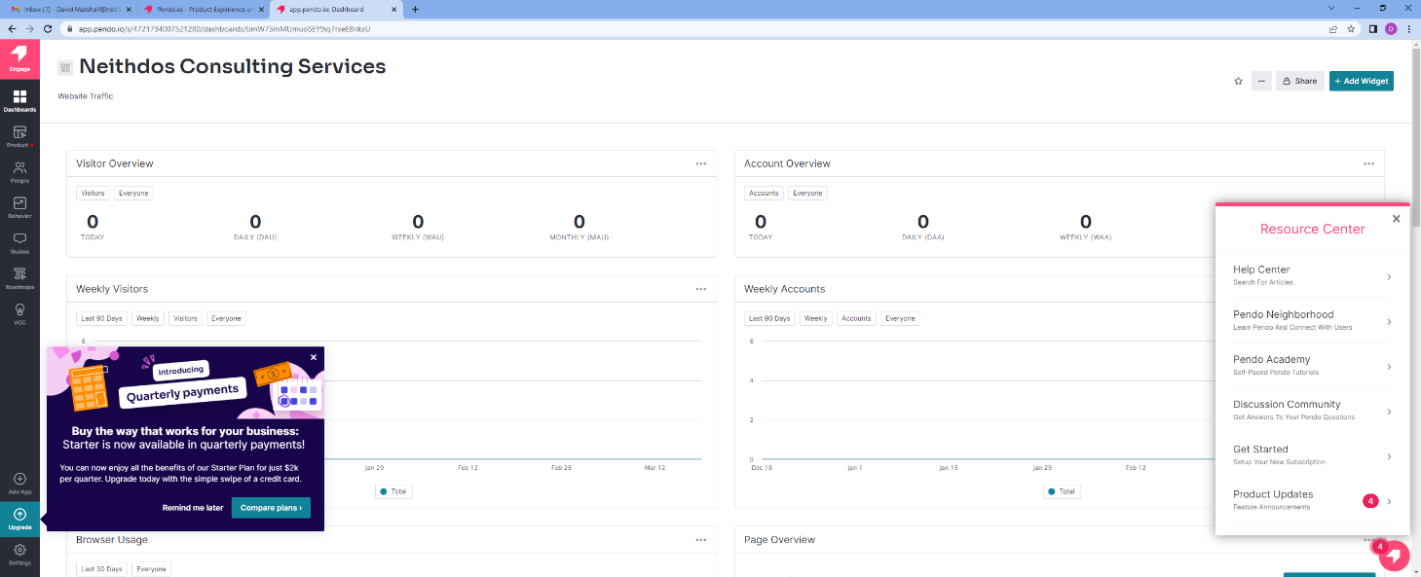
Figure 8: Pendo Resource Center

- Click Guides in the toolbar on the left-hand side of the dashboard.

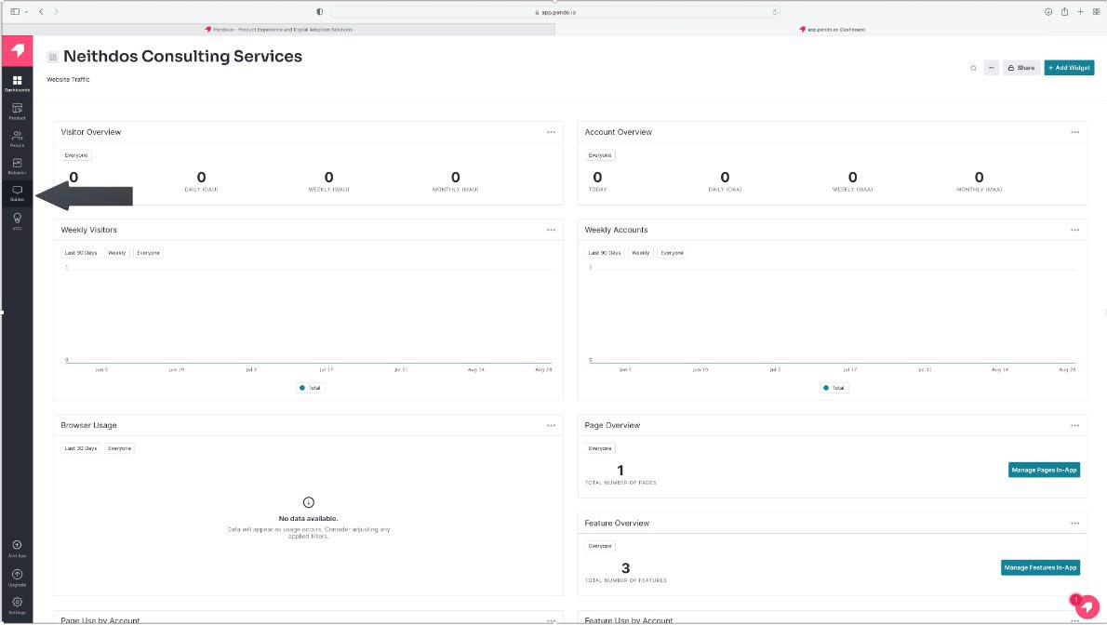

Figure 9: Guides option
- Click Guides for the Guides menu—the Guide dashboard displays.
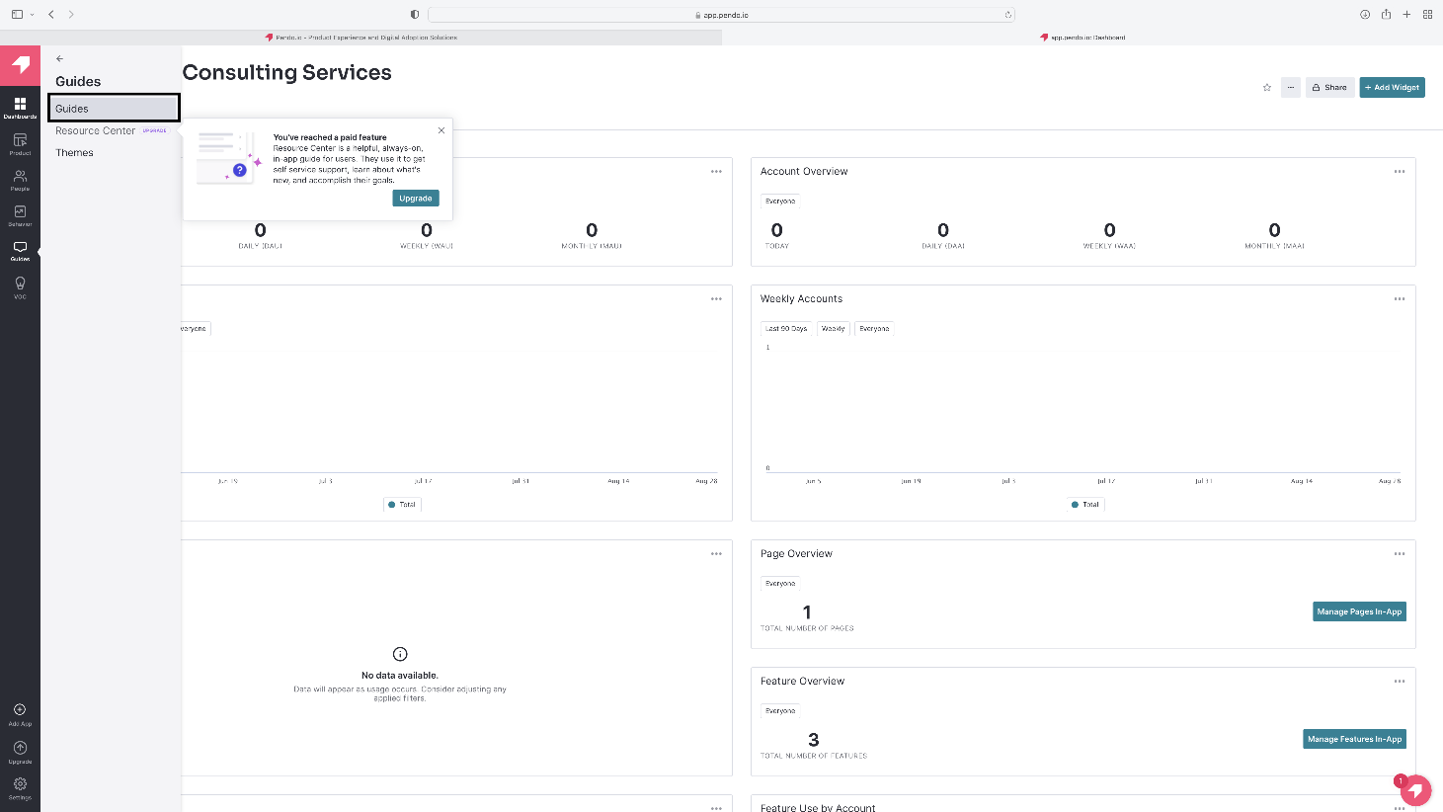

Figure 10: Guides option from the Guide menu

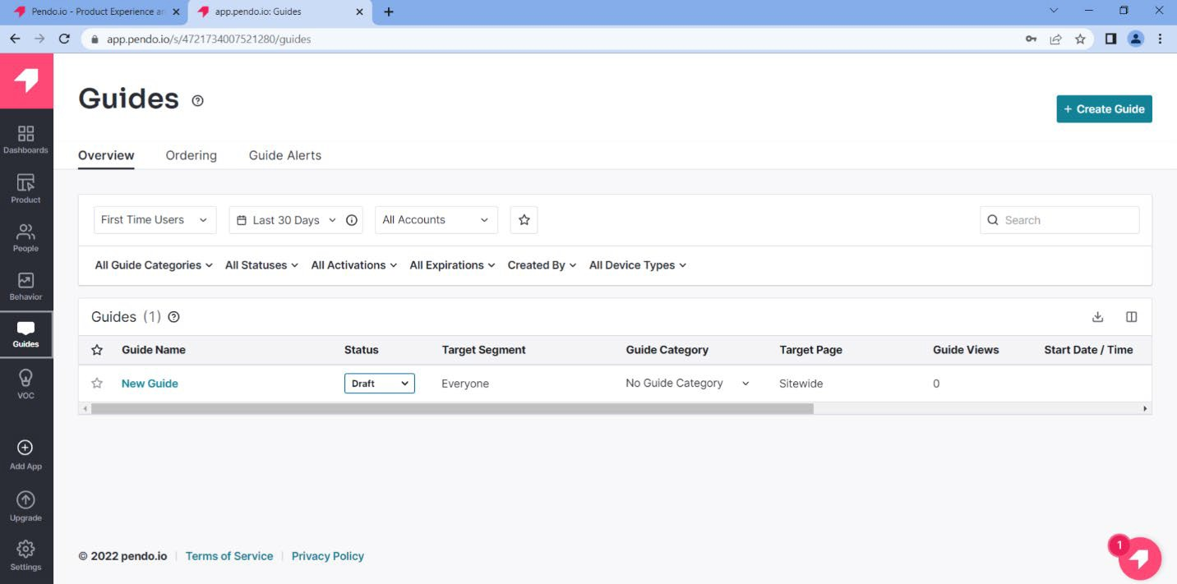

Figure 11: Guides dashboard

- Click +Create Guide.

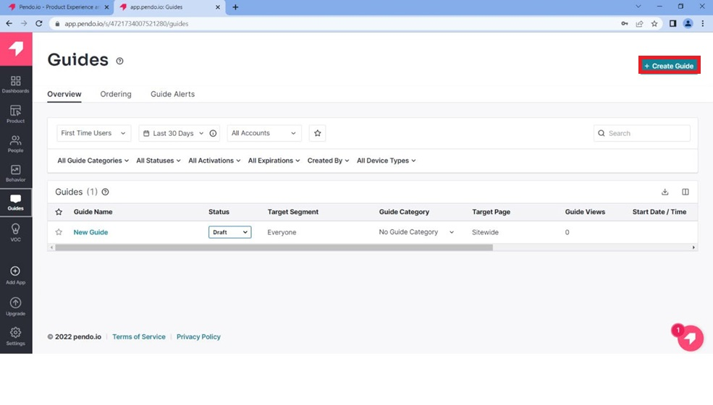
Figure 12: +Create Guide button
- Select Default from the Theme pull-down menu.

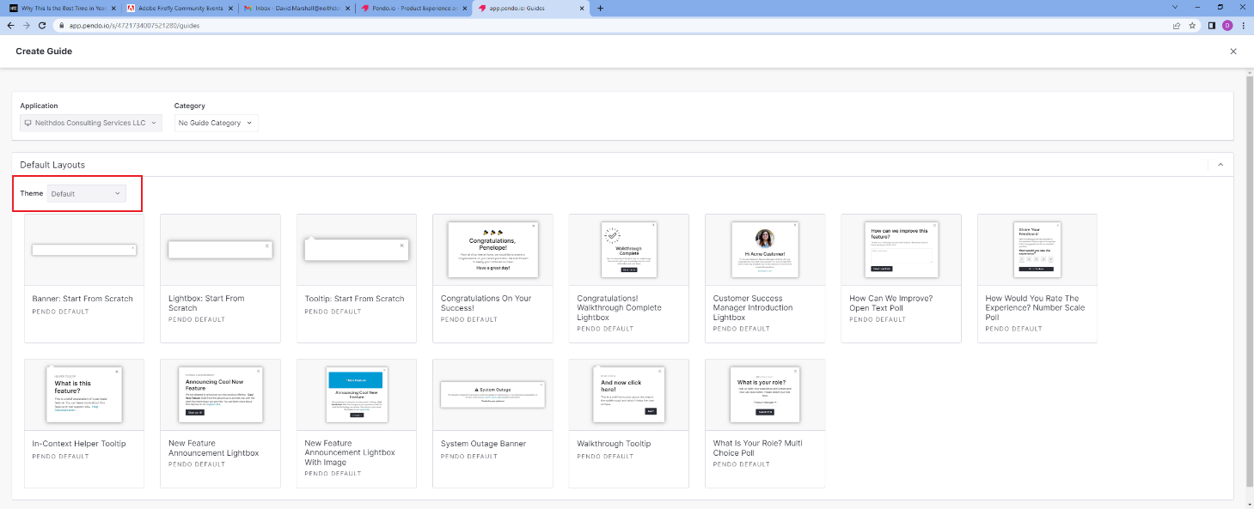
Figure 13: Theme pull-down menu

- Select the guide's theme. For this guide, we will select “Lightbox: Start from Scratch.”

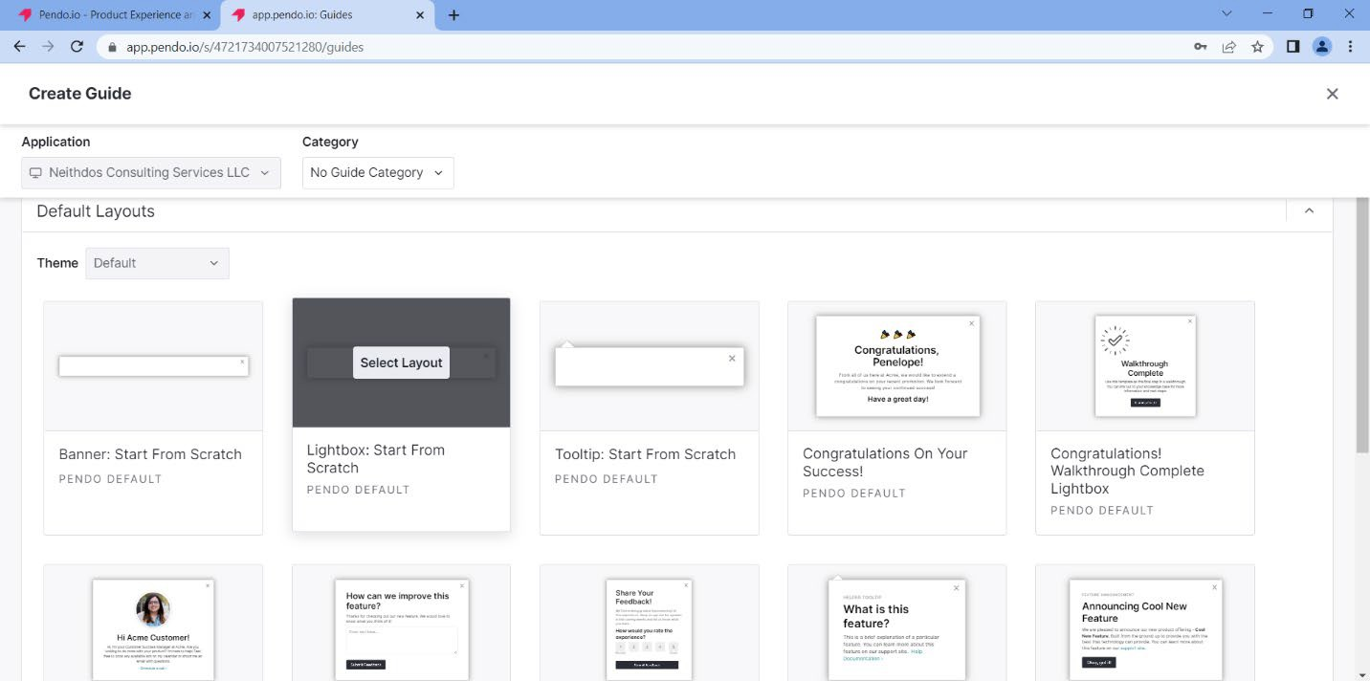
Figure 14: Selecting a theme
- Click Select Layout.
- Create a name for the guide in the blue highlighted area.
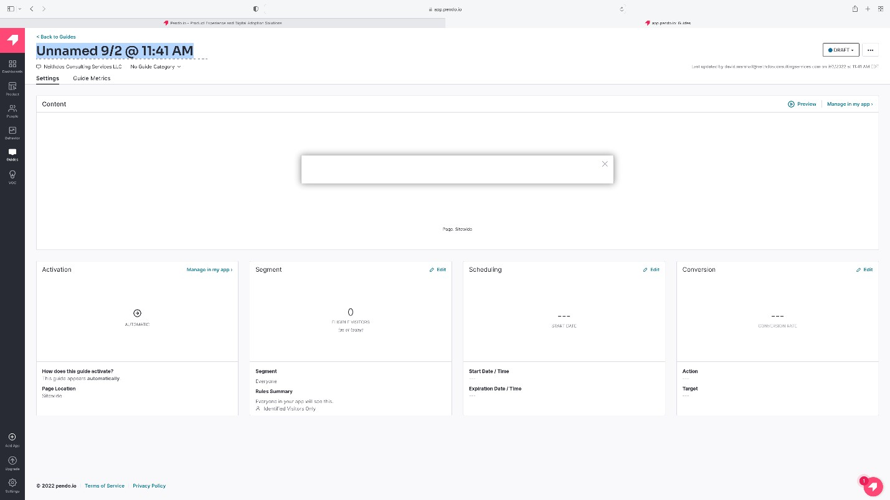
Figure 15: Create a name for the guide

- In the Content area, type in the website URL where the customer’s name will be displayed. For this example, we will use https://www.neithdosconsultingservices.com

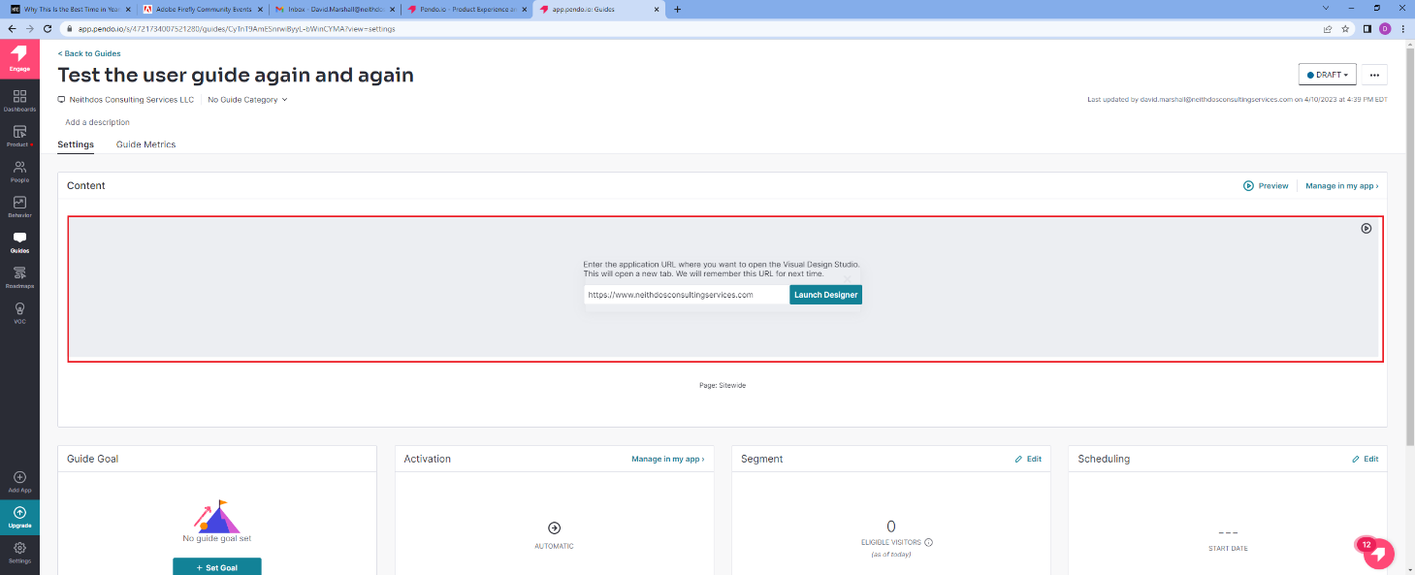
Figure 16: Enter URL

- Click Launch Designer.
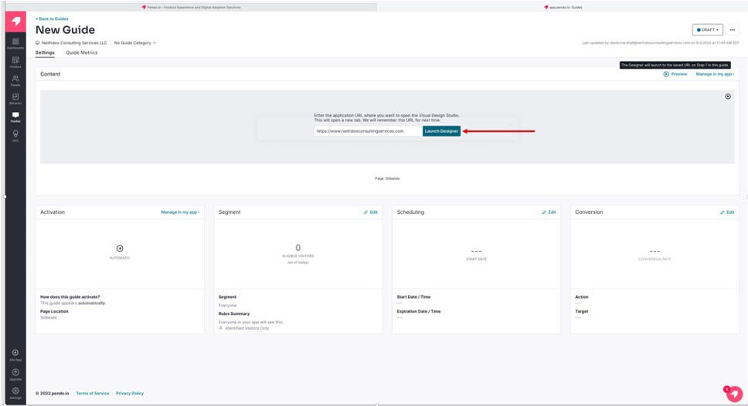
Figure 17: Launch Designer

- Click +Click to Add Content on the Edit Container.

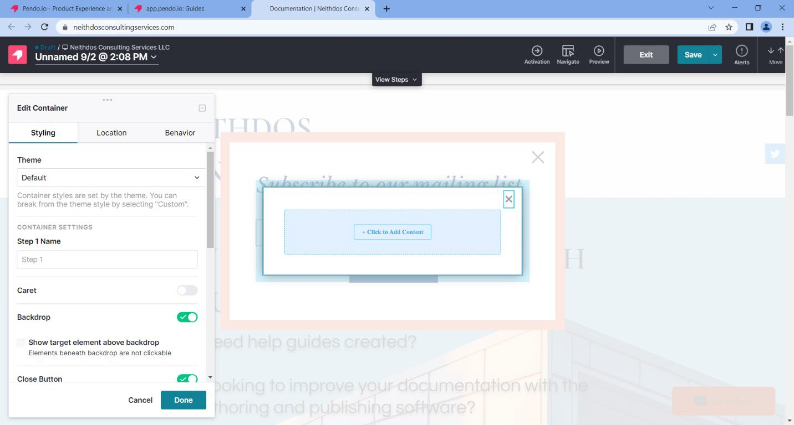
Figure 18: +Click to Add Content
- Select Text under Building Blocks

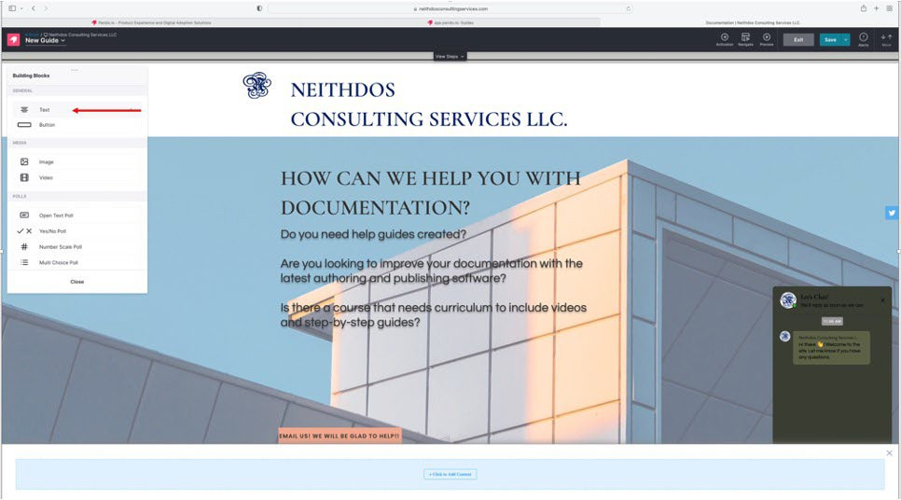
Figure 19: Text option
- Select Custom under Theme Style.
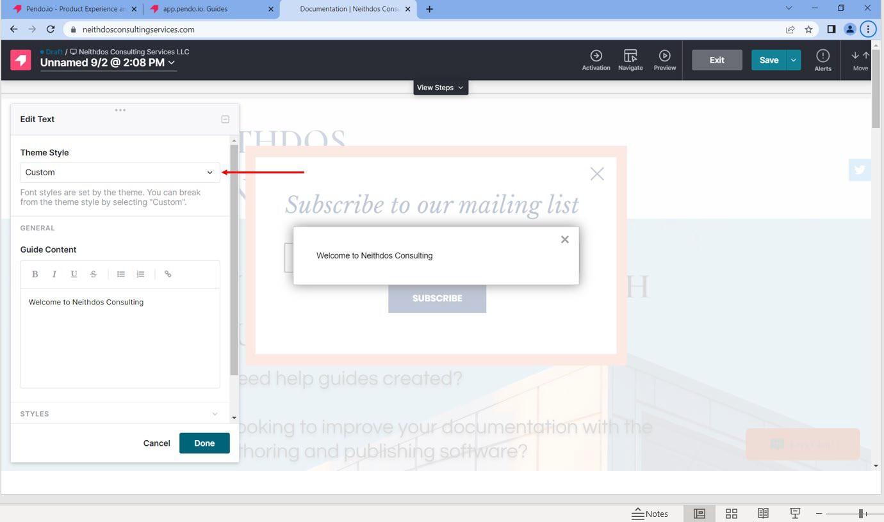
Figure 20: Custom option

- Type the message in the Guide Content area. In this example, we will use “Welcome to Neithdos Consulting.:

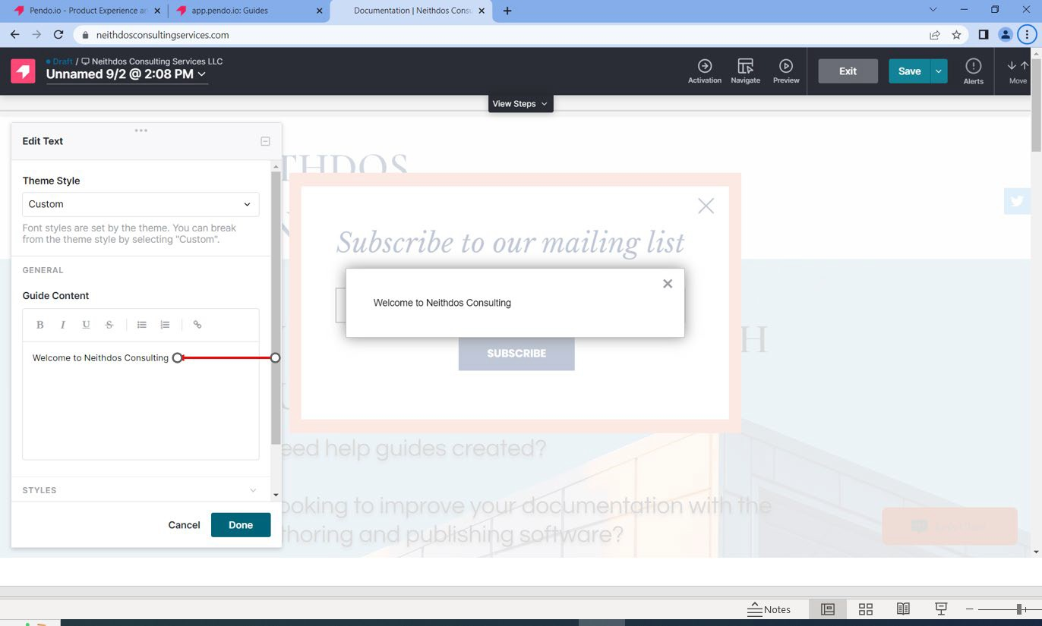
Figure 21: Customer Message
- Click Done.
- Click Save in the upper right corner.

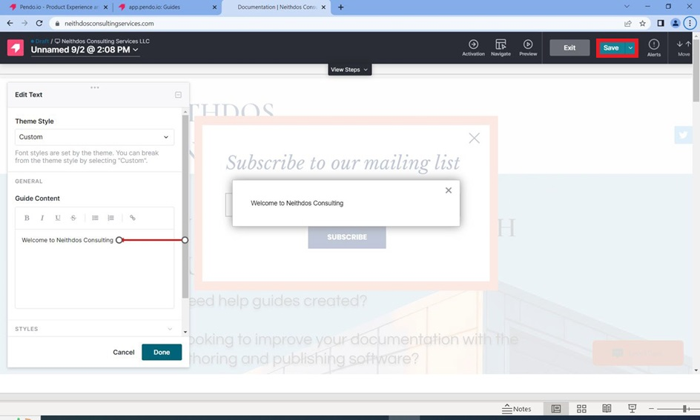

Figure 22: Save button
- Click Exit.

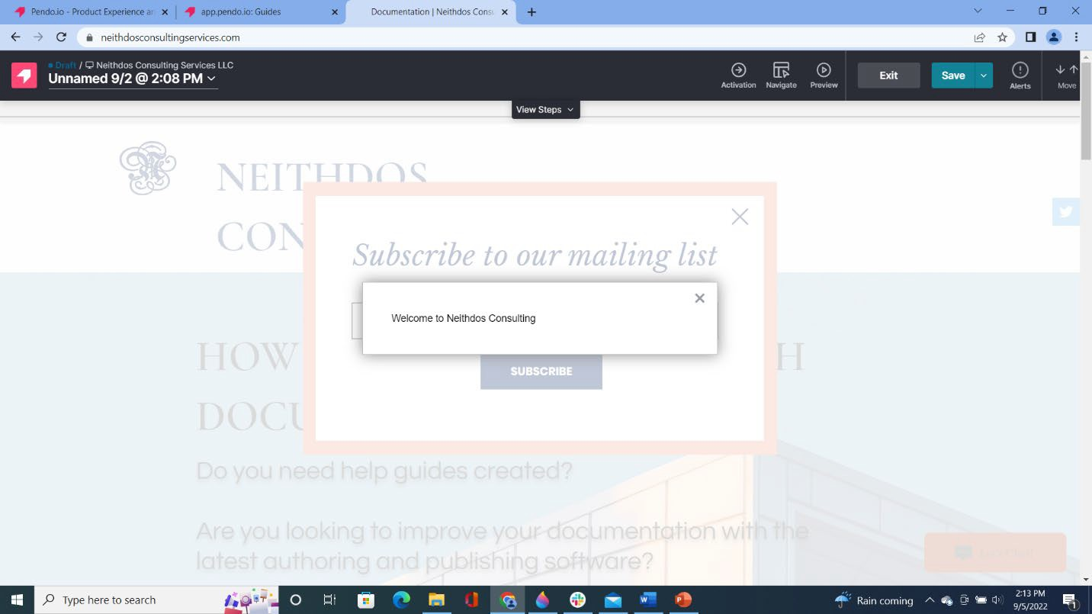

Figure 23: Exit button
- Click Preview. The message appears on the website.

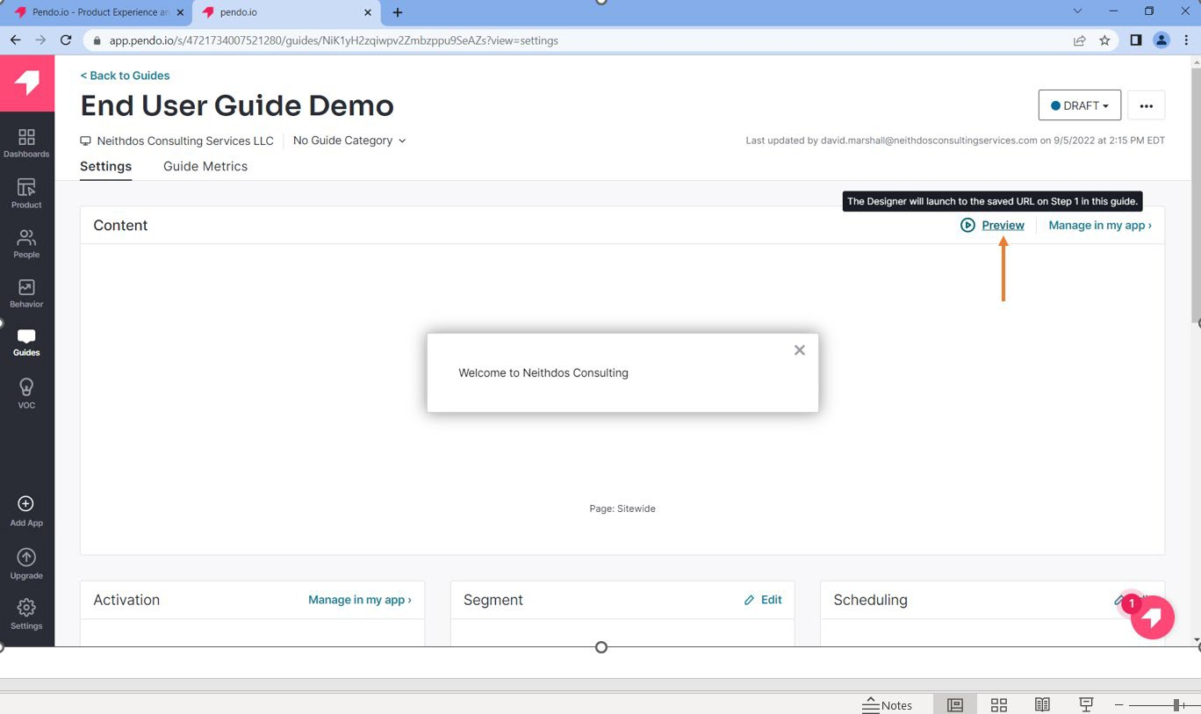
Figure 24: Preview option

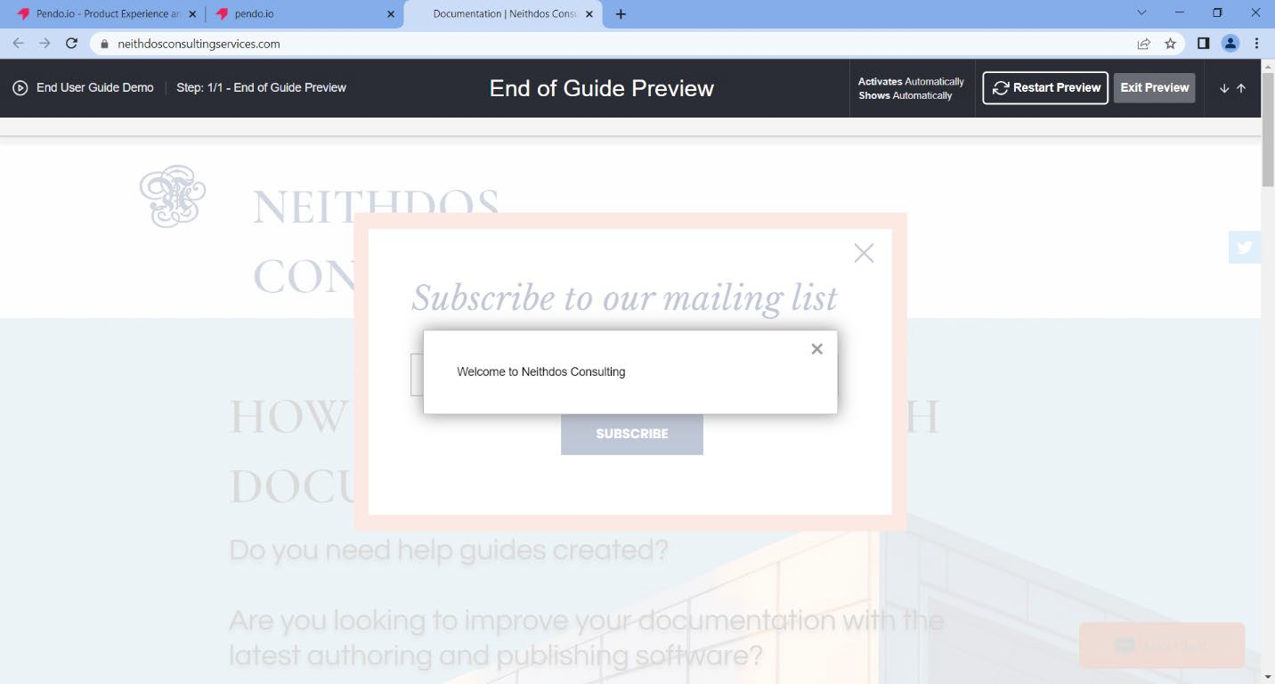
Figure 25: Website Message
- Click Exit Preview.

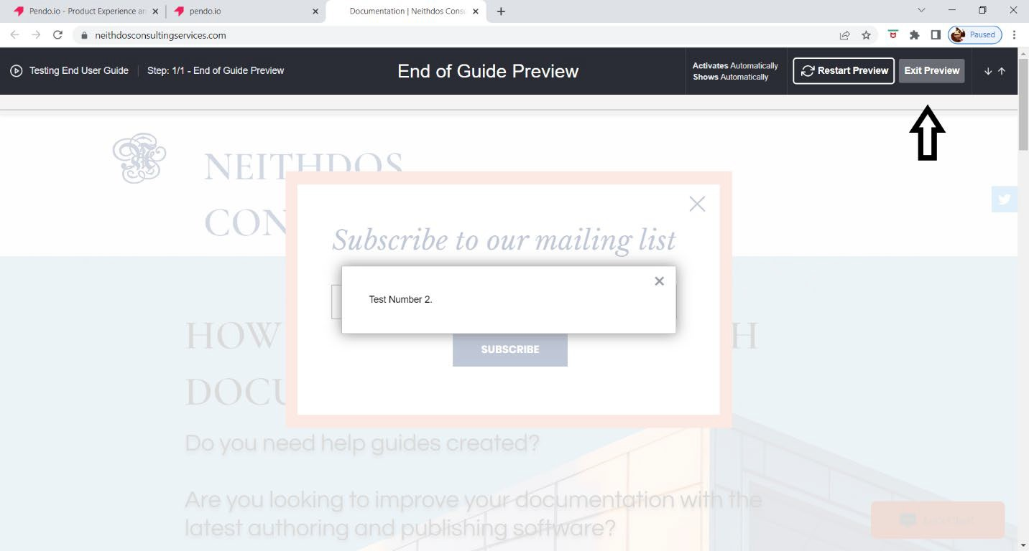
Figure 26: Exit Preview

- Click Back to Guides. The newly created guide is listed in the Guides Dashboard.

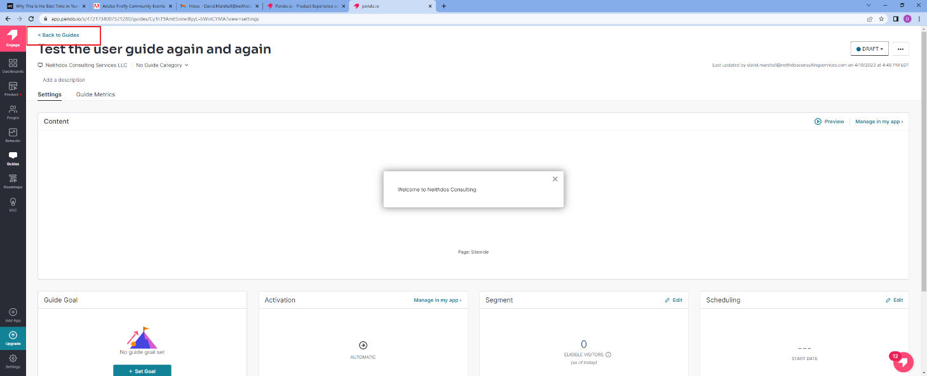
Figure 27: Back to Guides

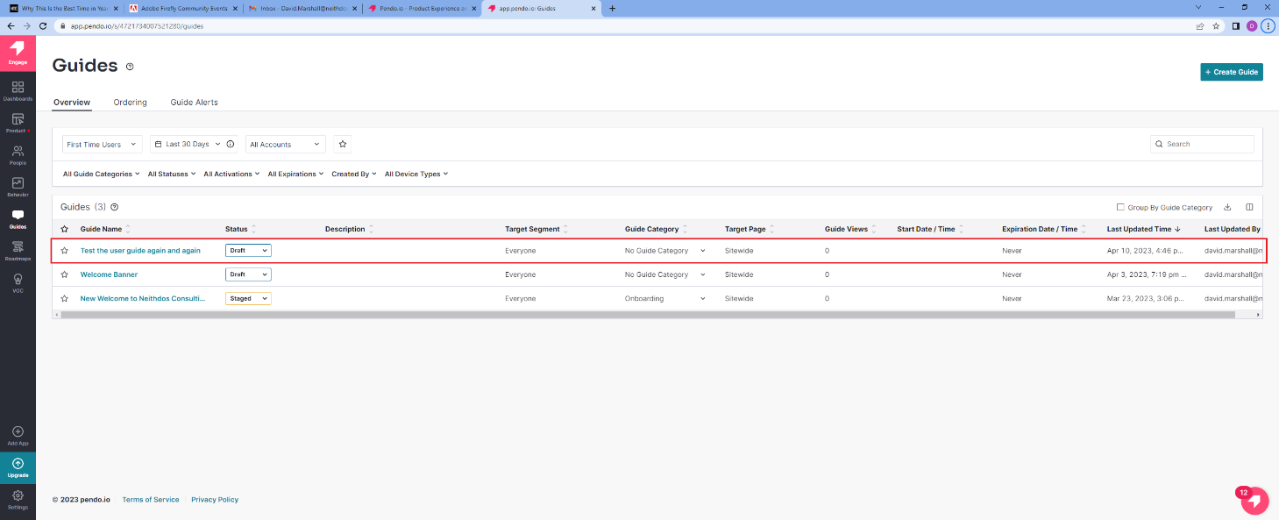
Figure 28: The newly created guide is listed

