How to Create a Customer Message Using Pendo

Steps:
- Go to https://www.pendo.io using your favorite web browser.
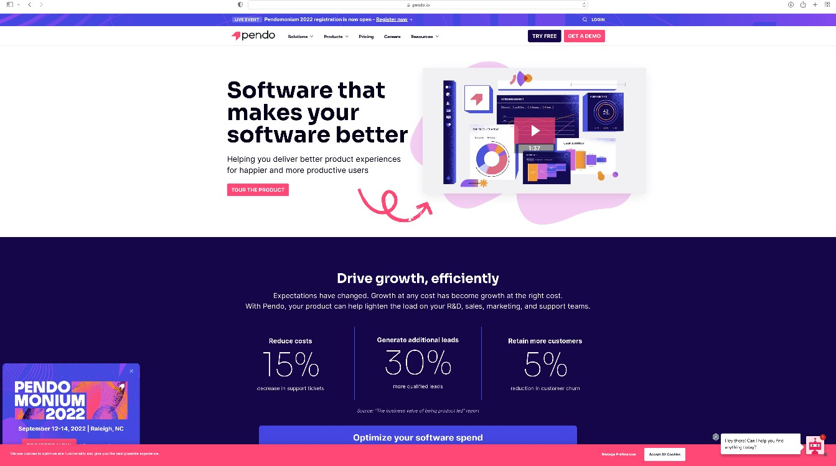
  - Note: For the best results, you should use Google Chrome.
Figure 1: Pendo Welcome Page

- Click the login button on the toolbar.
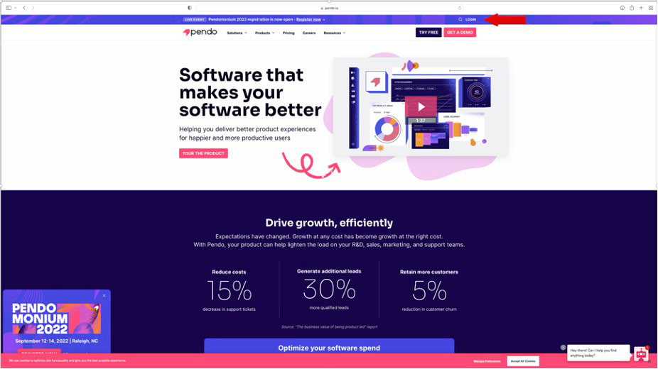

Figure 2: Pendo Login

- Enter the email address associated with the account and click Sign In. The password page displays.
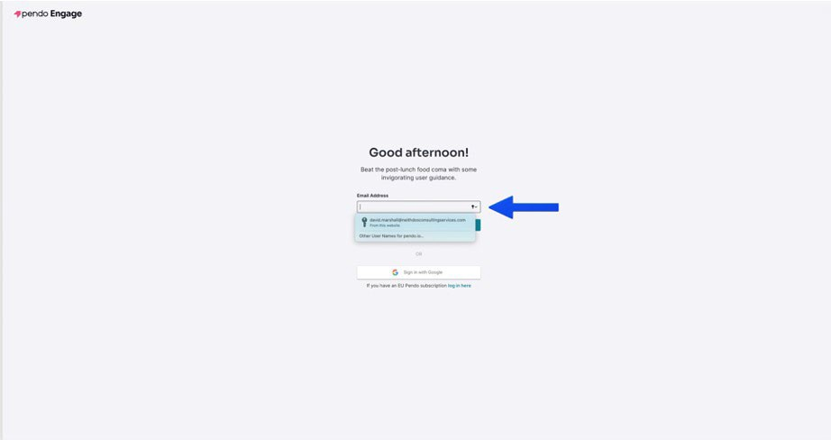
Figure 3: Enter Email Address

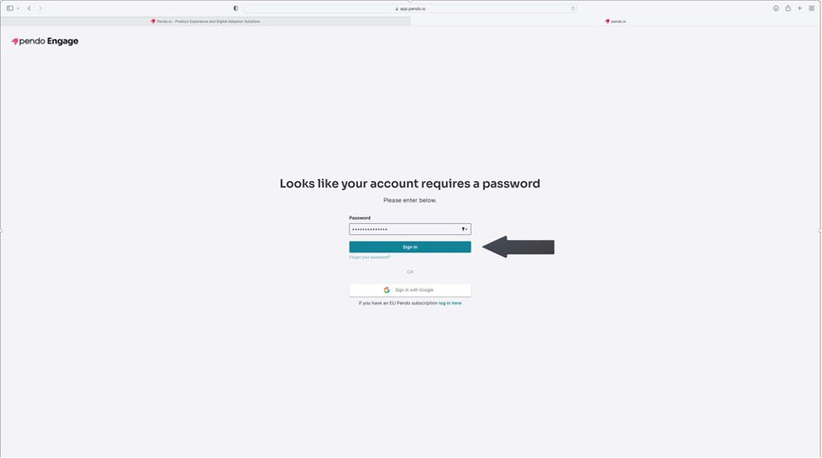

Figure 4: Click Sign In

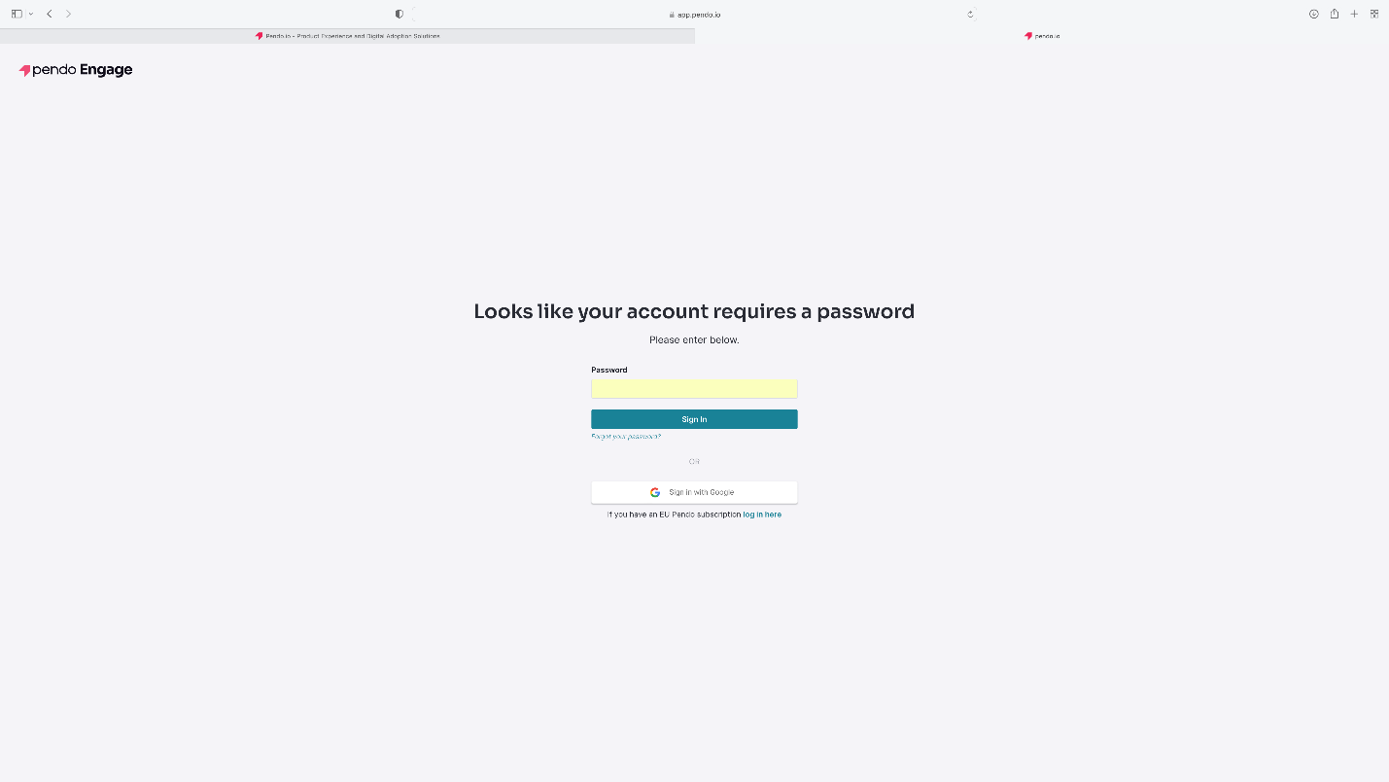
Figure 5: Password Page

- Enter the password associated with the account and click Sign In.
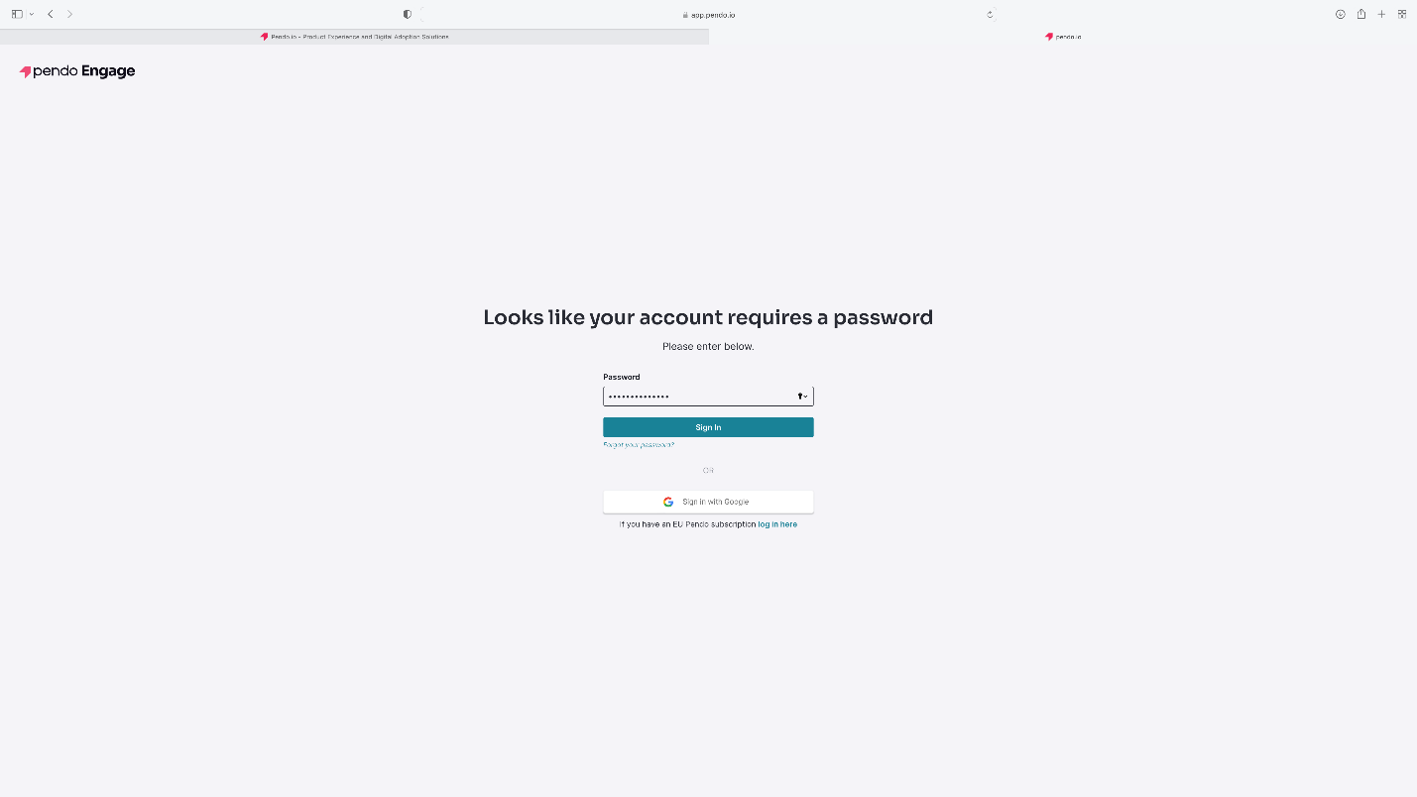
Figure 6: Enter Password and Click Sign In

- The Pendo Dashboard displays.
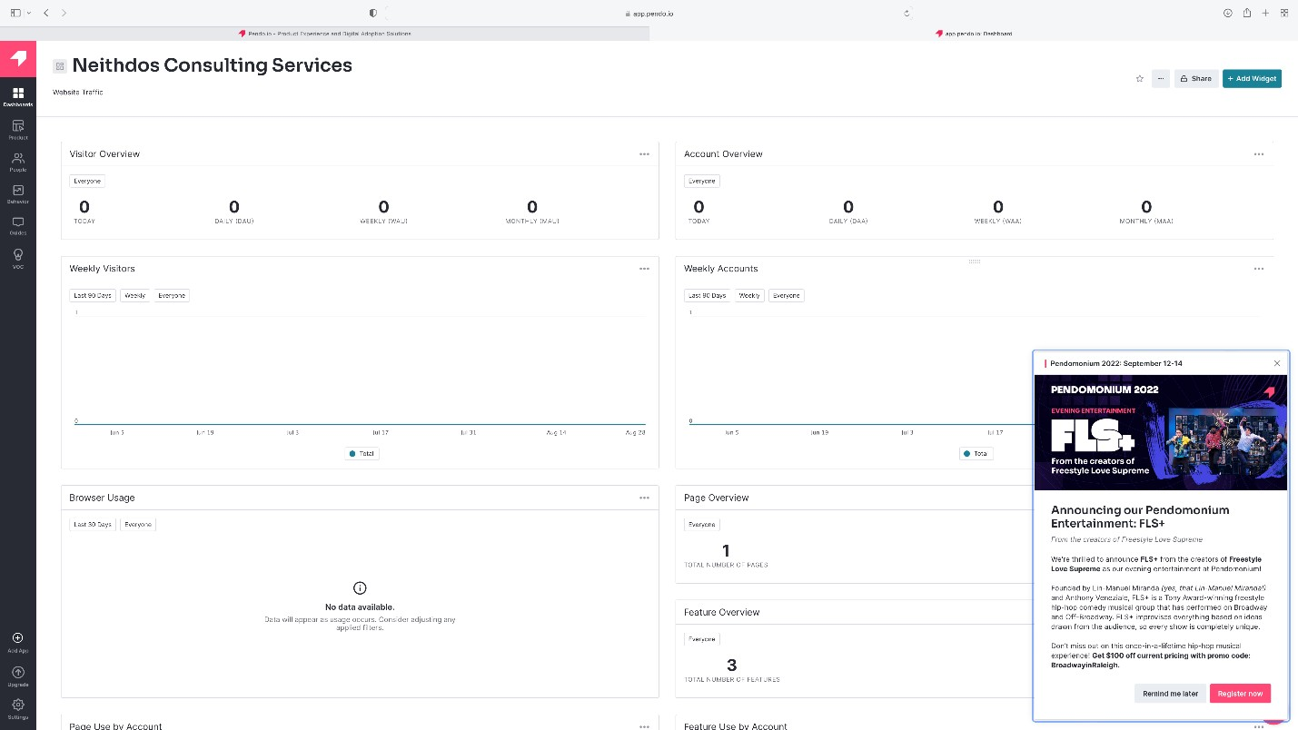
Figure 7: Pendo Dashboard

- To view announcements from Pendo, click on the Pendo logo on the lower right-hand corner of the dashboard. The Resource Center will open and display the announcements. To exit the Resource Center, click “X” in the upper right-hand corner.
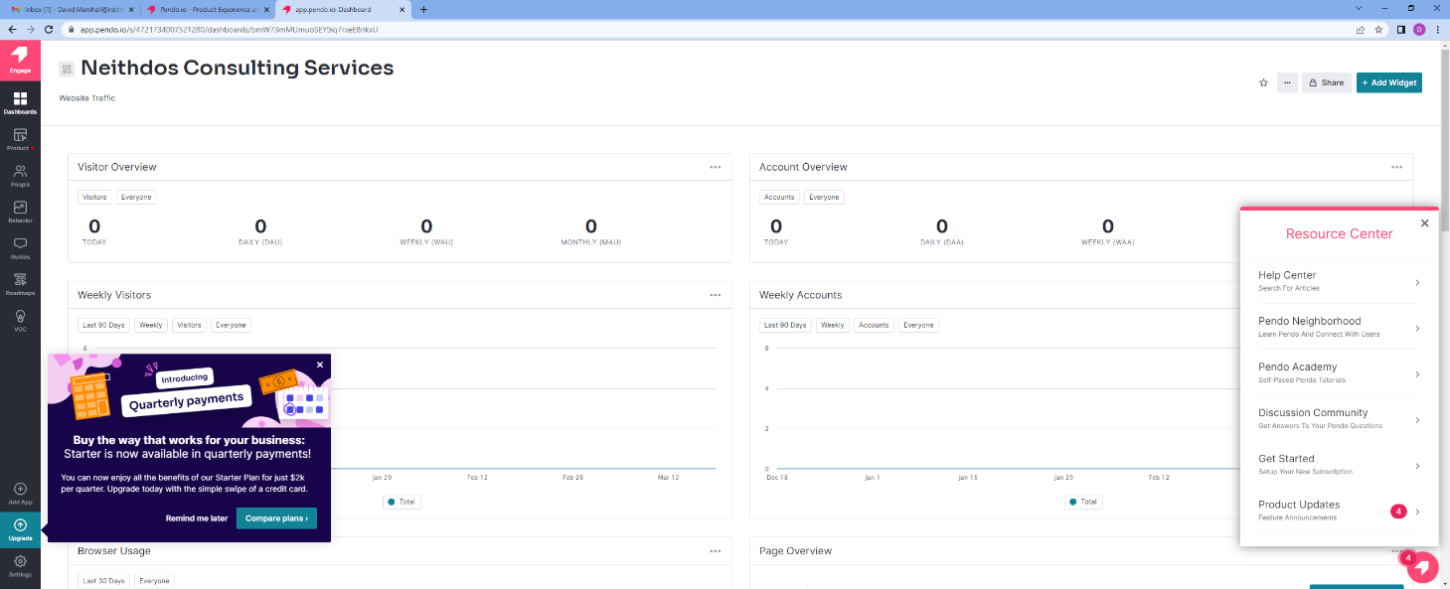
Figure 8: Resource Center

- Click Guides in the toolbar on the left-hand side of the dashboard.
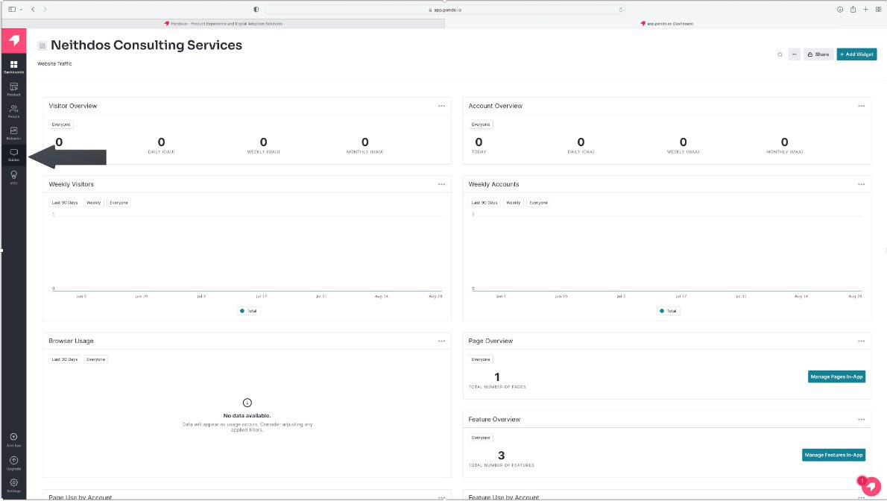

Figure 9: Click Guides

- Click Guides from the Guides menu. The Guide dashboard displays.

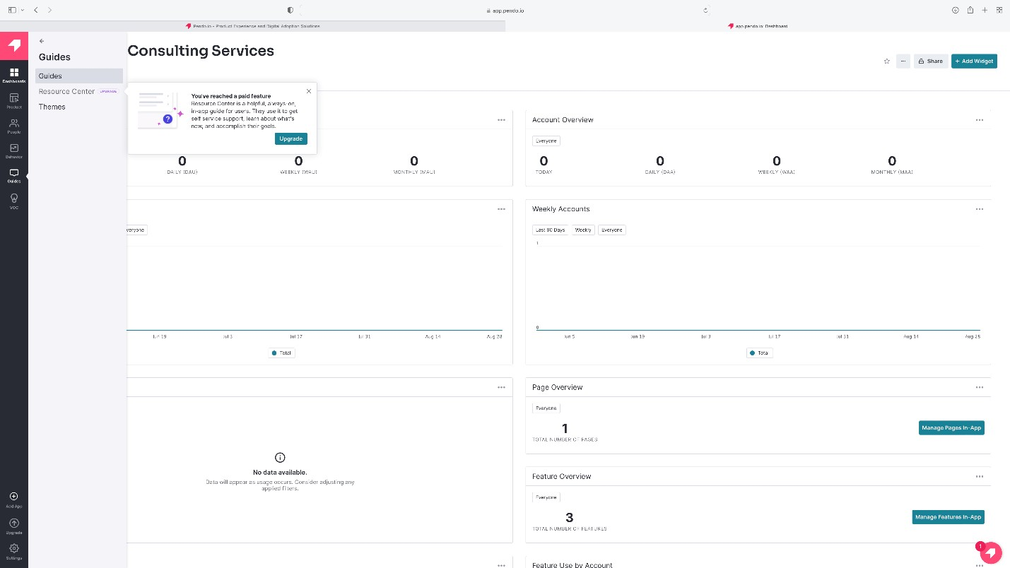

Figure 10: Click Guides from the Guide Menu

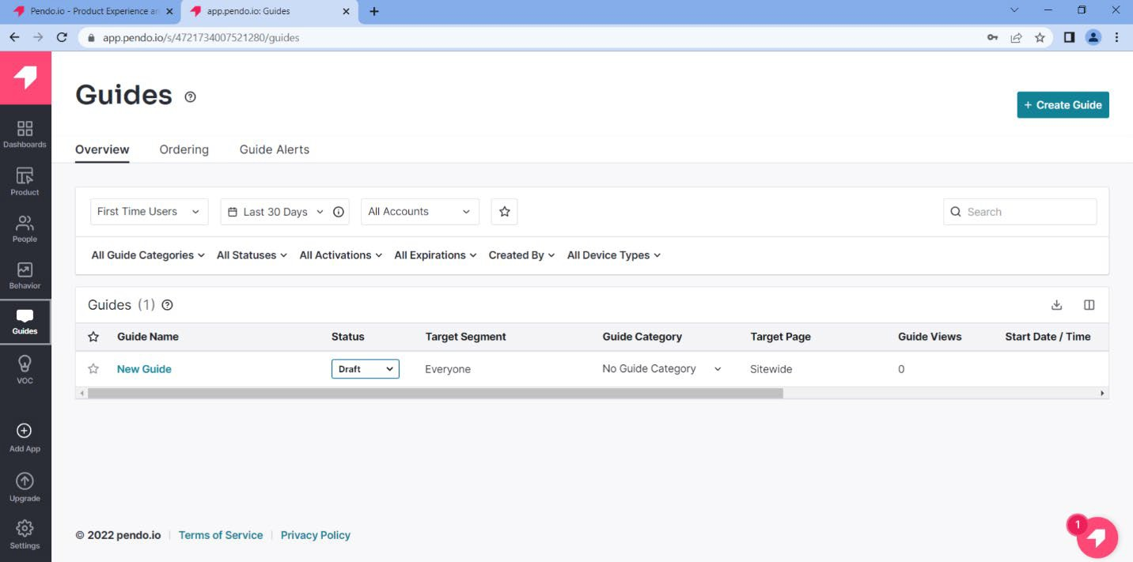

Figure 11: Guides Dashboard

- Click the “+ Create Guide” button.
- From the Create Guide dashboard, select Default from the Theme pull-down menu. Then, select the guide's theme. For this guide, we will choose “Lightbox: Start from Scratch.”
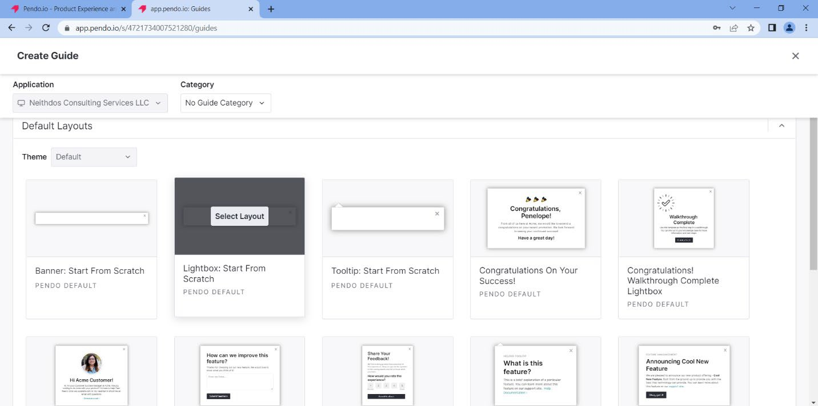
Figure 12: Default Layout: Lightbox Start from Scratch

- Click the Select Layout button.
- Create a name for the Guide in the Blue Highlighted area.
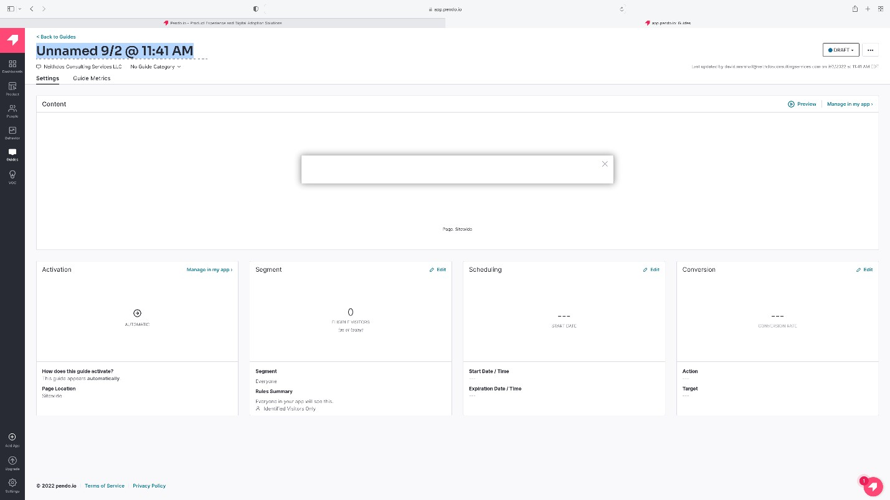
Figure 13: Name the Guide

- In the Content area, enter the website’s URL, where the customer’s message will be displayed. For this example, we will use https://www.neithdosconsultingservices.com.
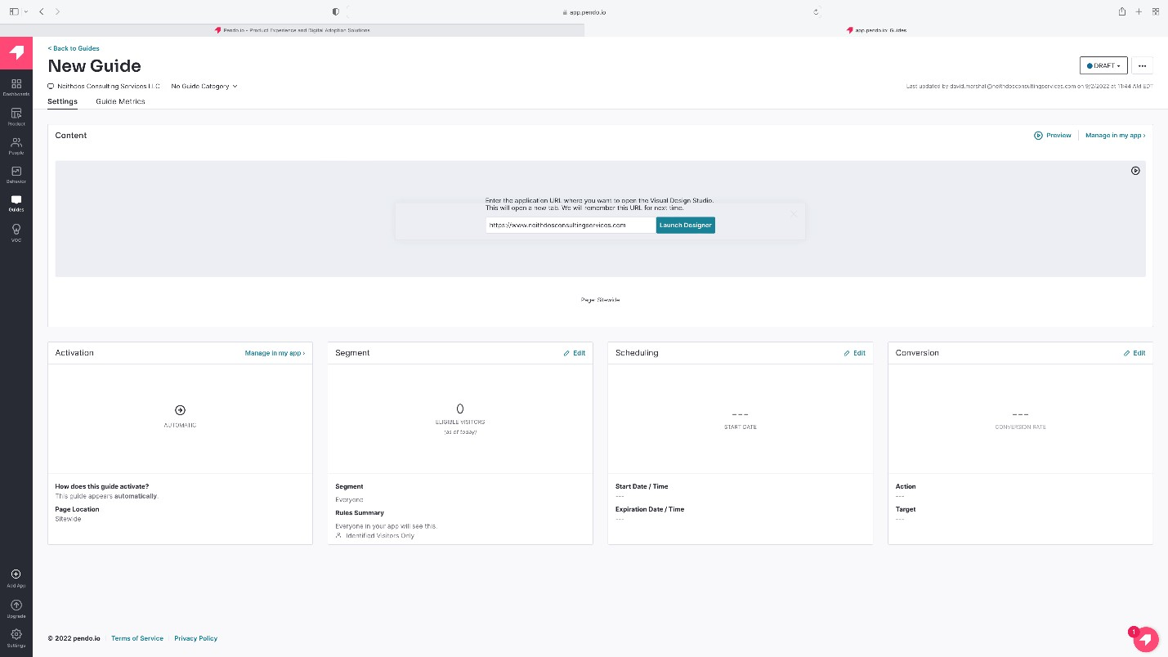
Figure 14: URL of the Website

- Click “Launch Designer”
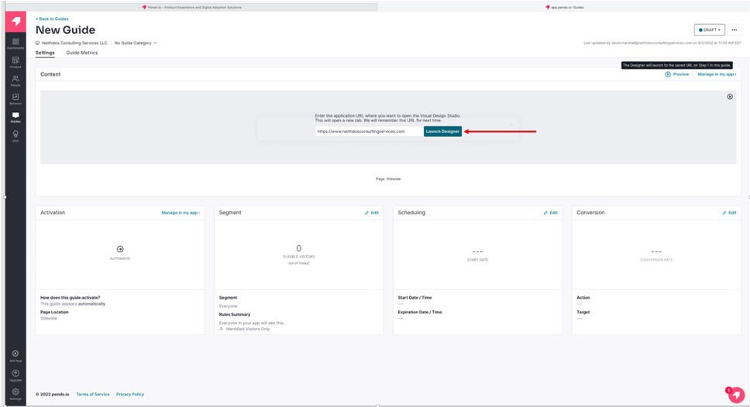

Figure 15: Launch Designer

- The website with the Edit Container menu displays.
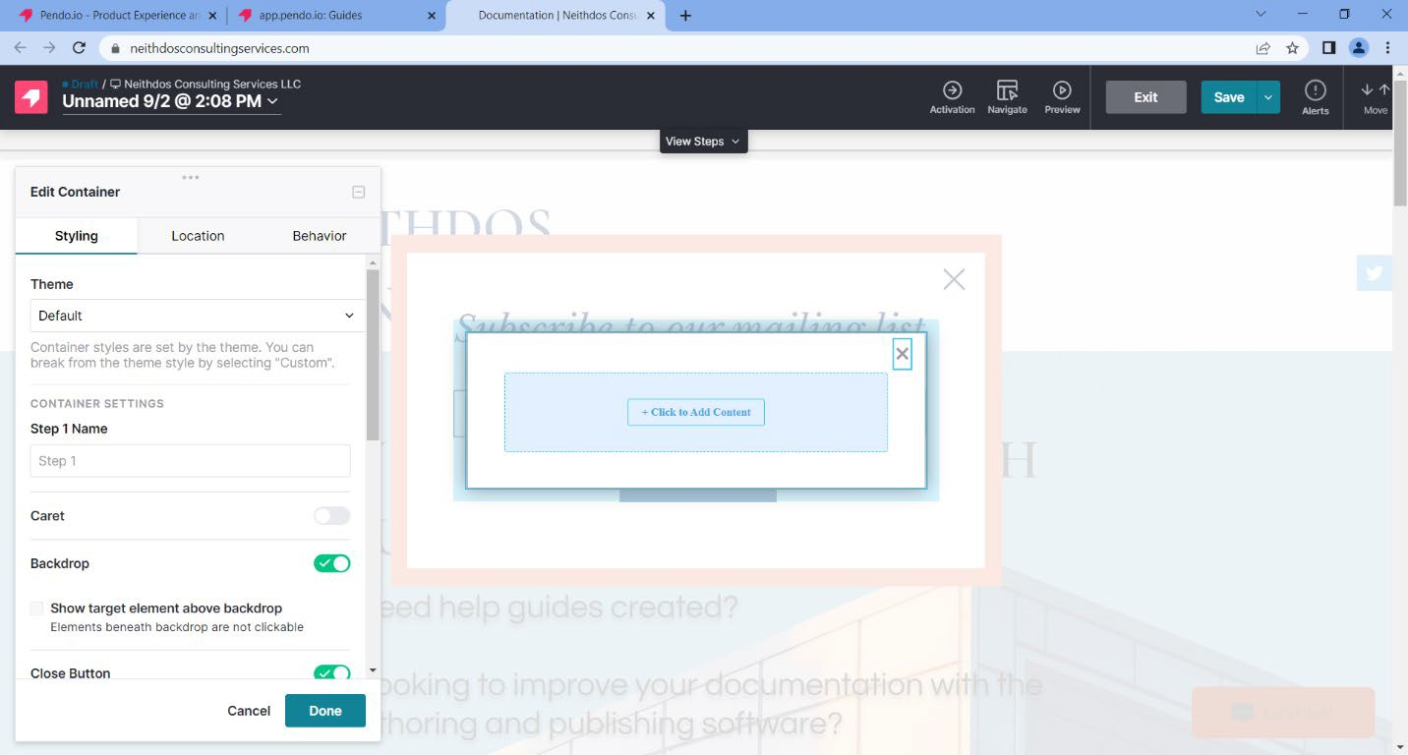
Figure 16: Website with the Edit Container

- Click “+ Click to Add Content.”
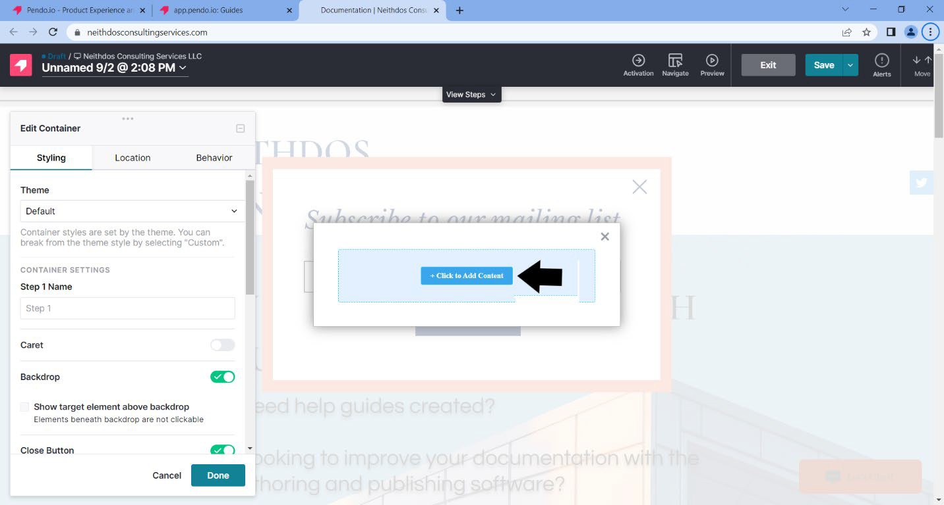
Figure 17: Add Content

- On the left-hand side, under Building Blocks – General, select “Text.”

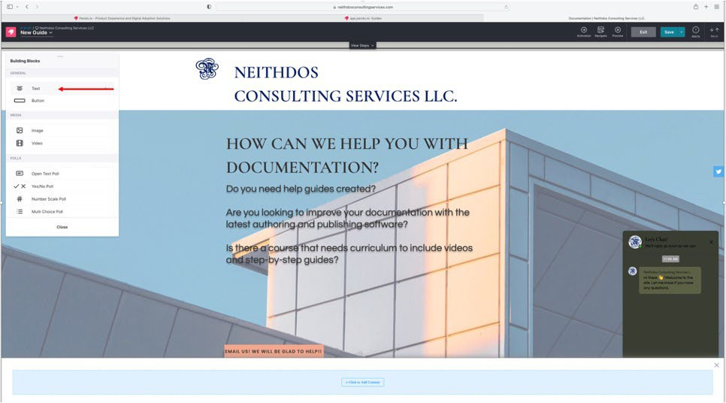

Figure 18: Text Building Block

- Select “Custom” from the pull-down menu on the left-hand side under Theme Style.
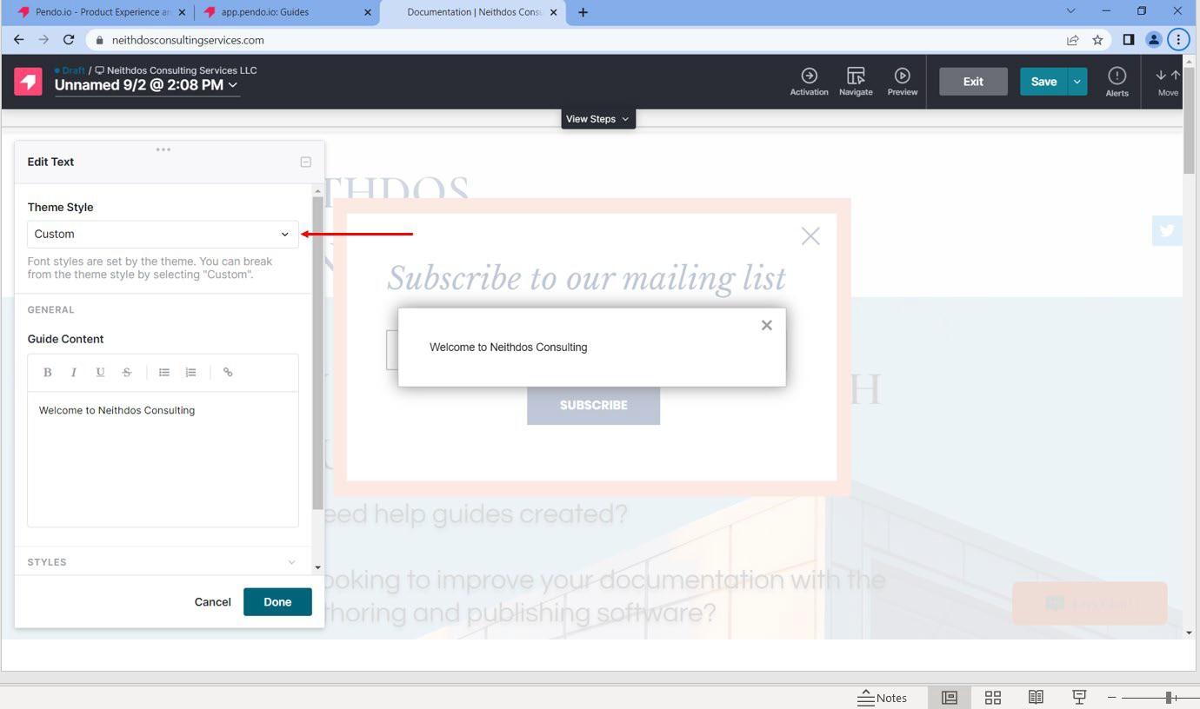

Figure 19: Theme Style – Custom

- In the Guide Content area, type the message or information.

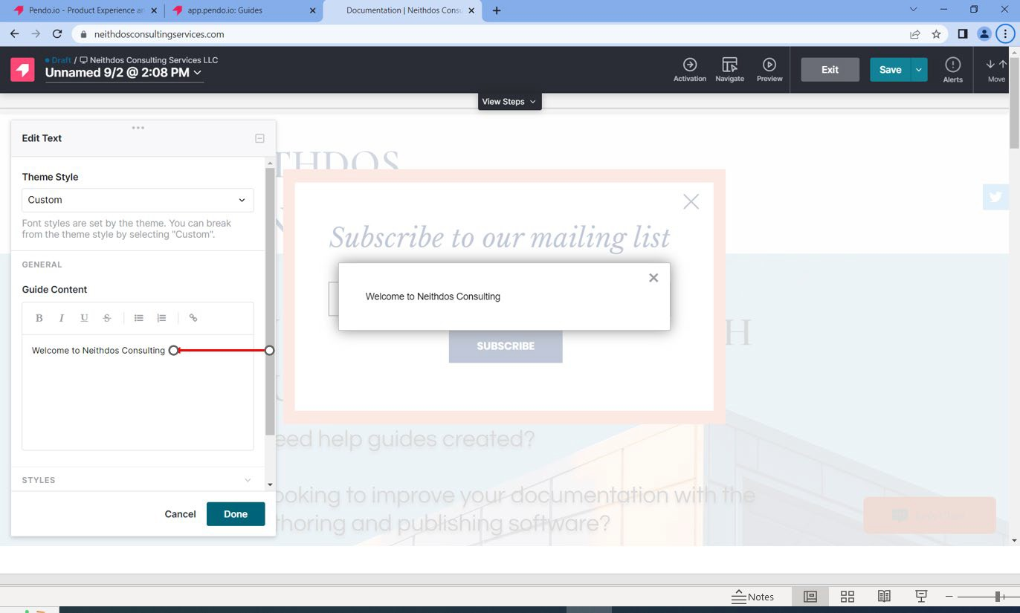

Figure 20: Customer Message

- Click Done.
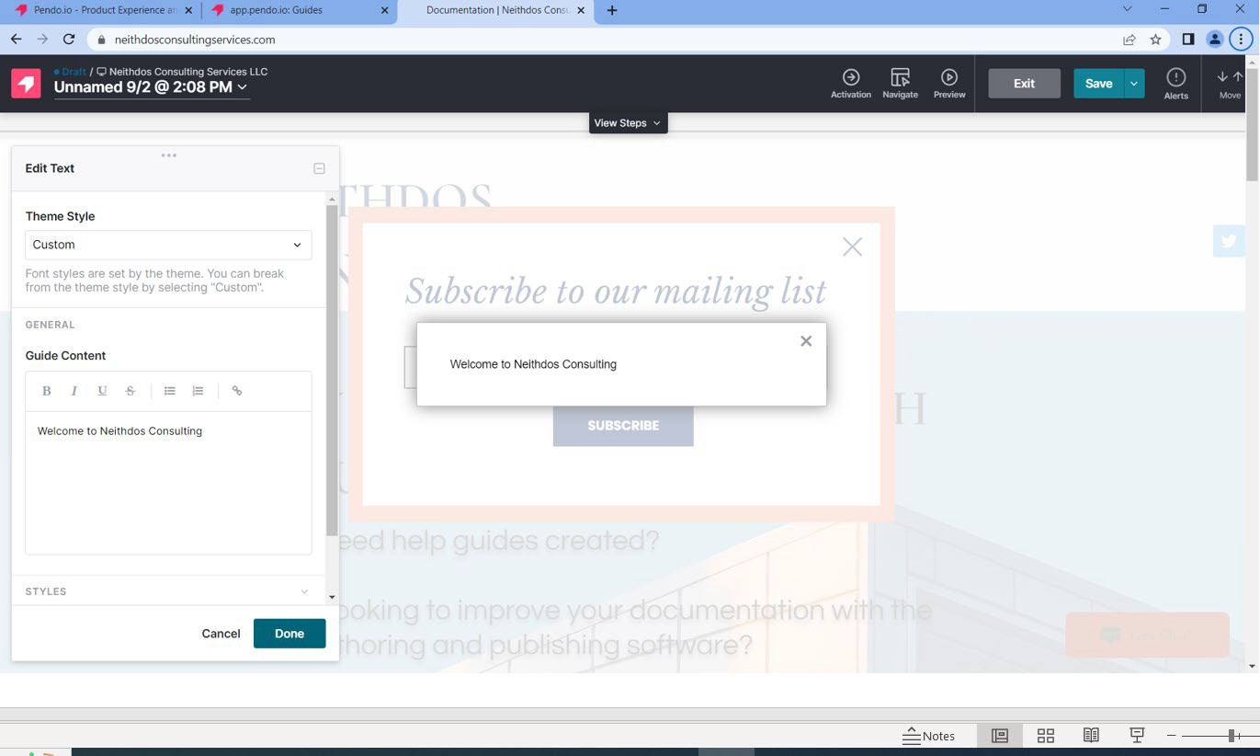
Figure 21: Theme Style – Done

- Click the “Save” button located in the upper right-hand corner.
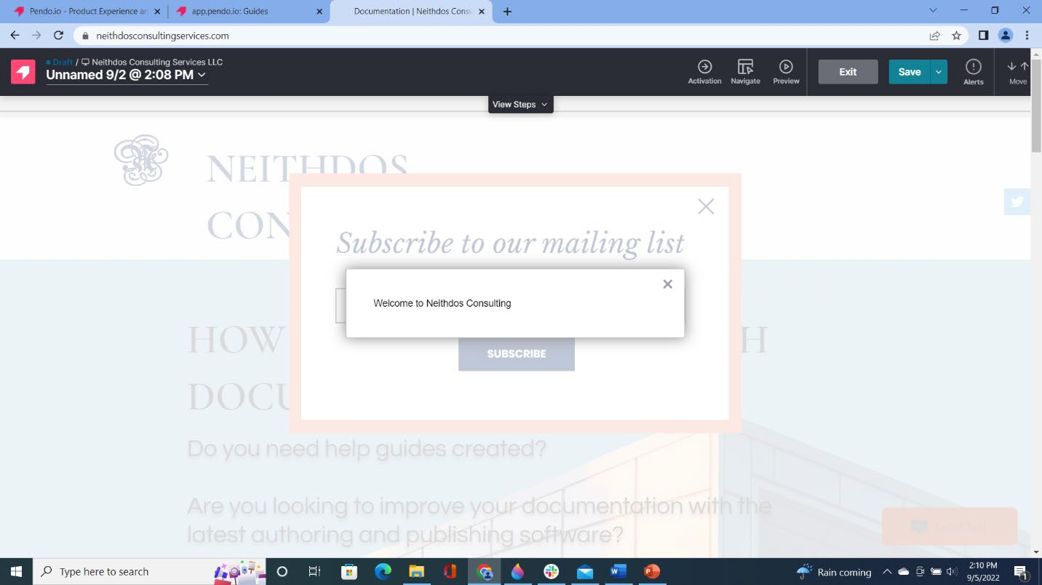
Figure 22: Save - Upper Right-Hand Corner

- Click the “Exit” button located in the upper right-hand corner. The Guide dashboard displays.
- Click “Preview” to test the newly created guide and the customer message.
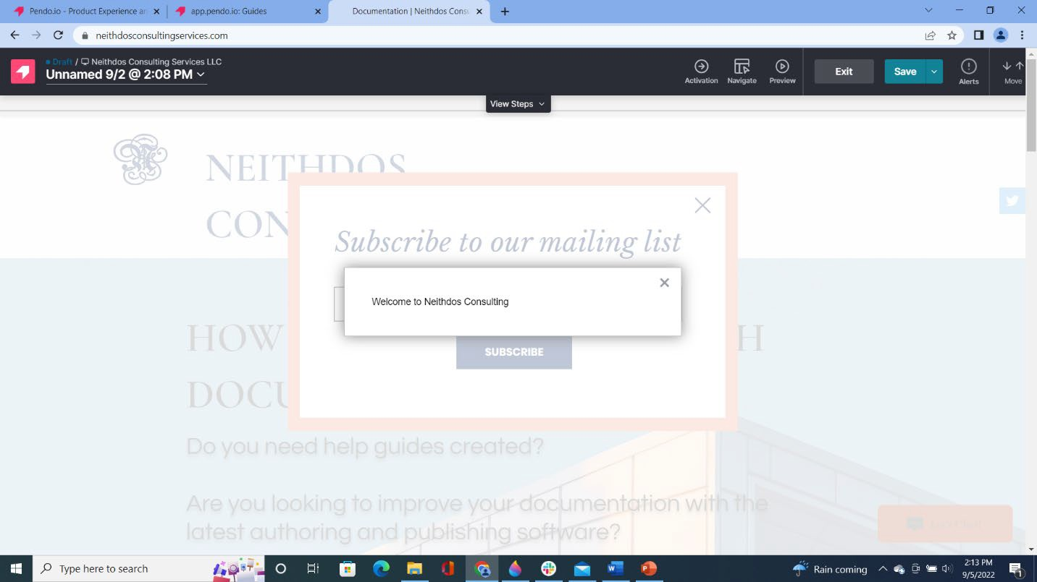

Figure 23: Exit - Upper Right-Hand Corner

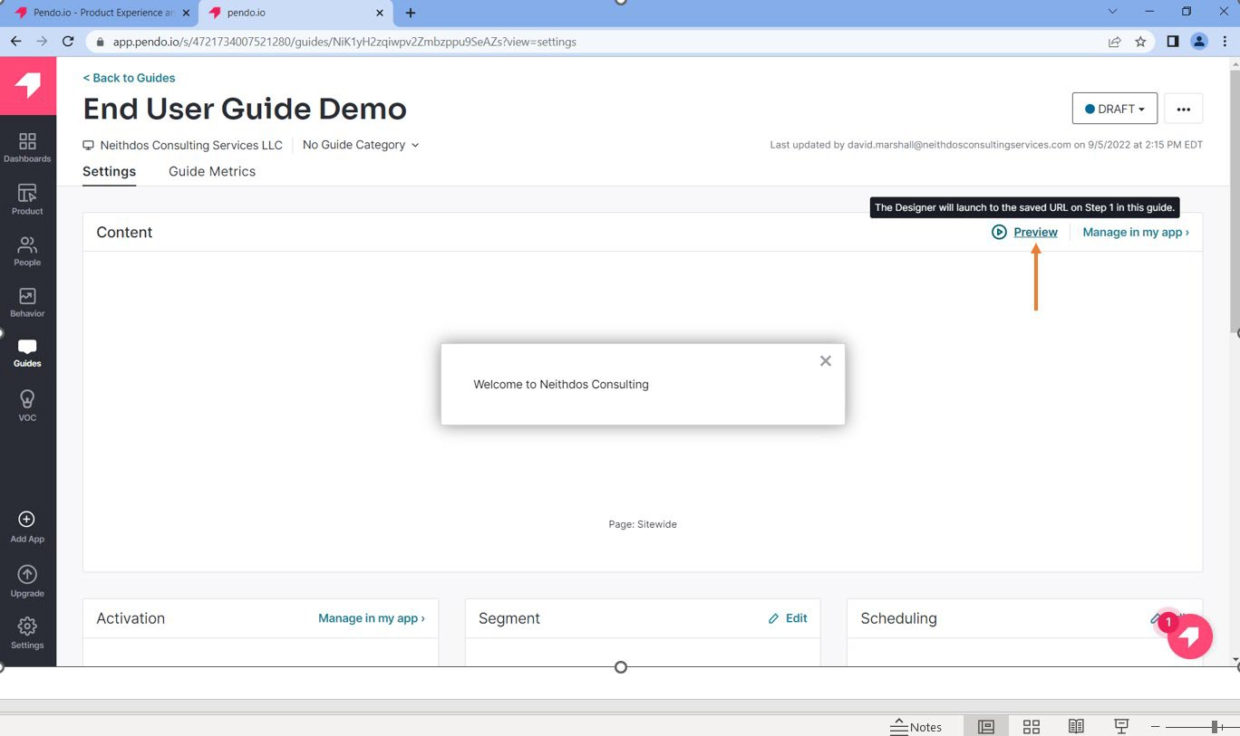

Figure 24: Click Preview

- The customer message will appear on the website.
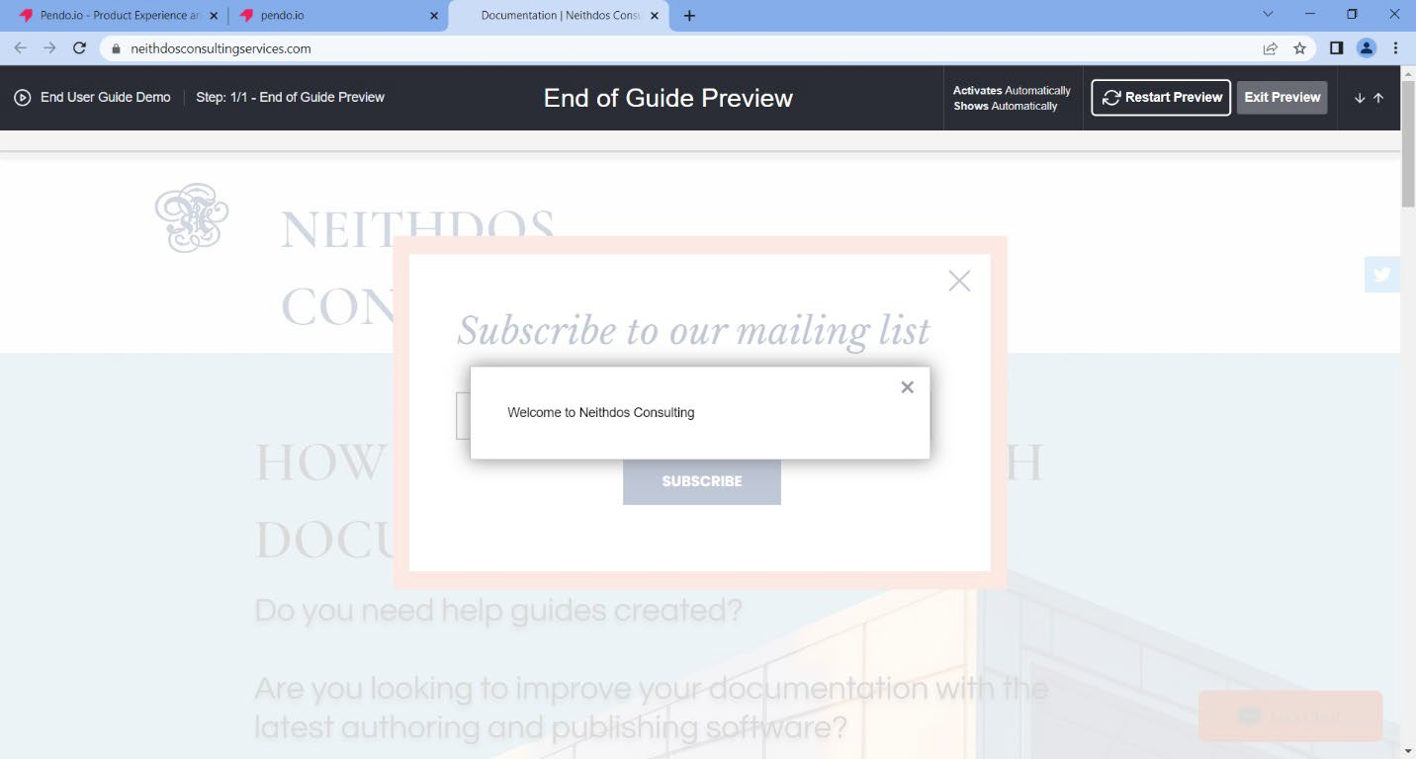
Figure 25: Website Confirmation

- Click Exit Preview.

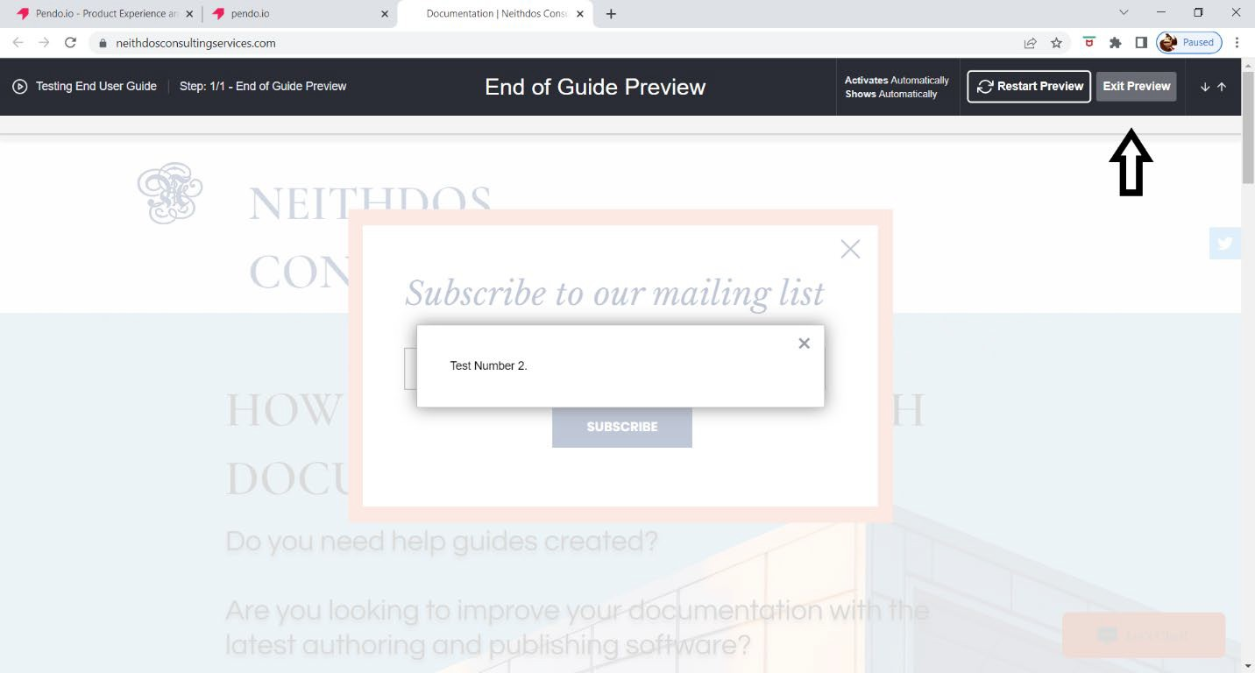

Figure 26: Exit Preview

